REMOTE DEFENSE OF DIPLOMA THESIS PROCEDURE

Preparation of a diploma thesis for defense using the APD system Archiwum Prac Dyplomowych – Archive of Diploma Theses)

  - At least one month before the planned date of the defense, the Employee of Student Service Center assigns the Student a Thesis Supervisor in the USOS system (as a thesis supervisor and as the first Thesis Reviewer) and fills in additional information necessary to handle the diploma thesis.
Note: in the USOS system, the form for entering data is available in the menu
"Students"->"Diplomas" -> "Diploma Theses by Person":

- you can enter a working title or any text (e.g. "Title of the work") as the title of the work. The final title of the thesis will be entered in the APD system by the Student himself (after the Supervisor's approval),
- the value of the "Work status in the APD system" field must be set to "To be modified (the student is to enter the abstract in the APD)", and the value of the "Should archive in APD" field to "Archive",
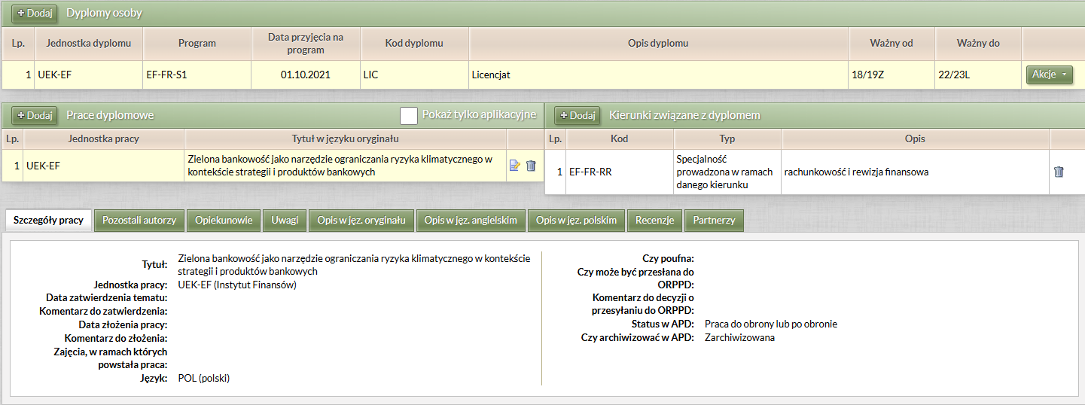
- after assigning a Supervisor as a Advisor (the "Advisors" tab), you can add him/her as a Reviewer by clicking on the "Add as review" button or enter him/her manually in the "Reviews" tab.

  - After entering the data on the diploma thesis into the USOS system, the Student and Supervisor gain access to the work in the APD system.
To log in to the APD system, you need to:
    - enter the address of the website (https://apd.uek.krakow.pl/ in your web browser, and then select the "Login" link (upper right corner of the screen),
    - a login form to the Central Authentication System (CAS) will appear, where you need to enter your ID and password.

Access to individual stages is possible after entering the "MY APD" tab in the main menu of the system:
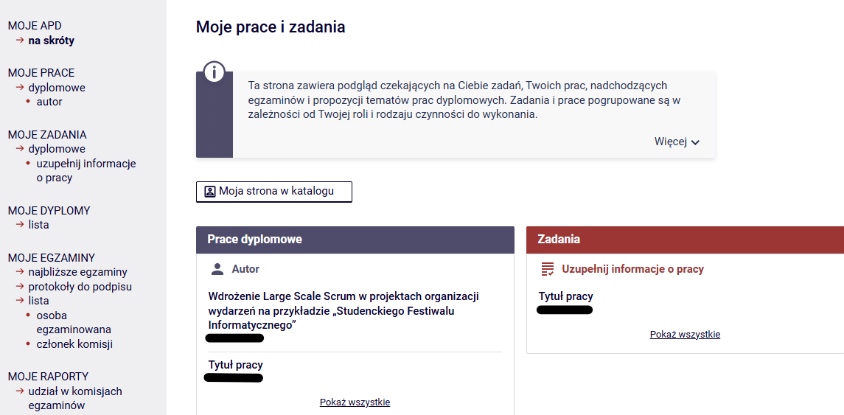

In the APD system, several steps (stages) must be completed, during which the work is placed in the system, checked by the anti-plagiarism system and evaluated by the Reviewers. The current progress of work is presented graphically on the path with Work Status, which shows what is to be done in a given step and who is responsible for its implementation:
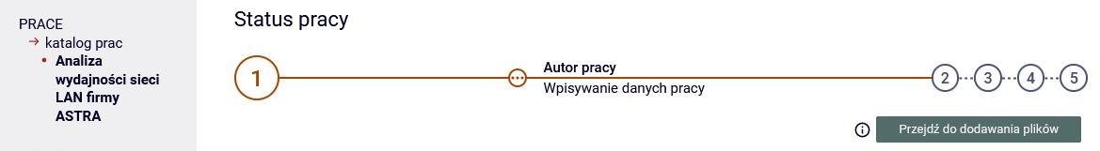

Note: in the APD system, all users have access to the backlog directory and search engine. The content of the paper and reviews are available only to the Author of the work – Student, Supervisor and Reviewer, Chairman of the Diploma Examination Commission, Employee of the Student Service Center, System Administrator.

  - After creating a task by an Employee of a unit serving Students, the Student is given the opportunity to upload the work to the APD system. The student performs step "1. Entering thesis data", i.e. enters – in Polish and English – the title of the work, abstract and keywords (fig. below). Then click on the "Proceed to Add Files" button and proceeds to step "2. Uploading thesis files".
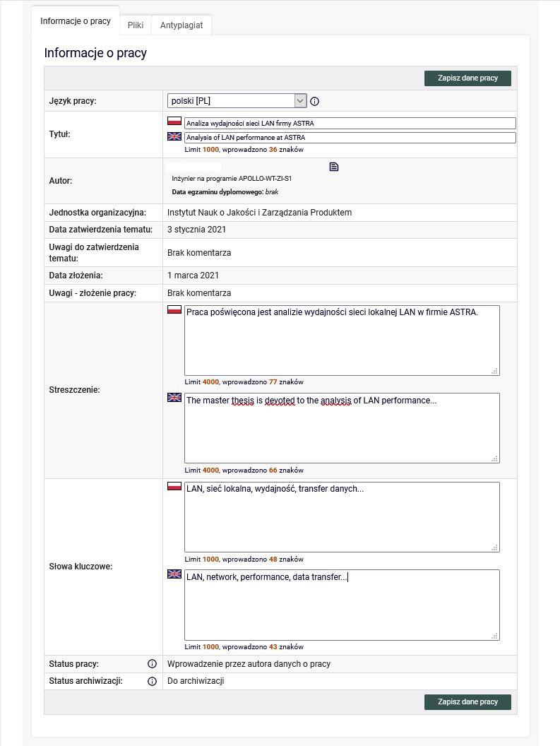

  - In the APD system, the Student performs step "2. Uploading thesis files", in which the thesis file in PDF format and possible attachments to the thesis is included, and the Statement on the use of artificial intelligence Appendix 3 to the Diploma Thesis Defense Procedure – file type "Other" (fig. below). Then click on the "Submit for approval by the Advisor" (Supervisor) button and proceed to step "3. Data Acceptance".

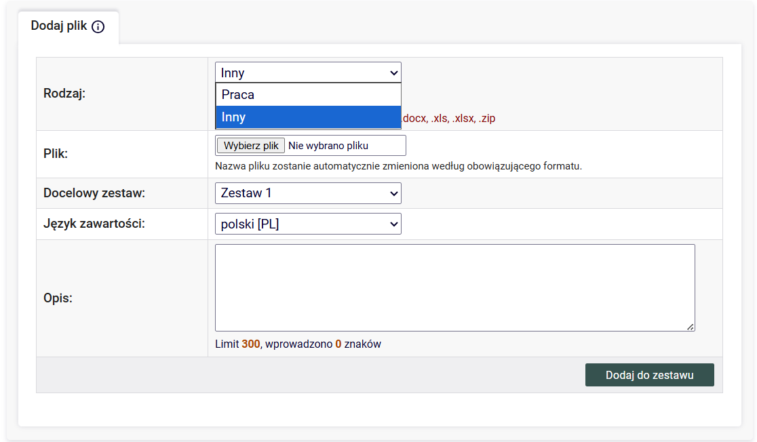

  - In the APD system, the Promoter performs step "3. Data acceptance", i.e. checks the work submitted by the Student and additional data (title, abstract, keywords), and then:
- if the work needs to be improved, he clicks on the "Submit for improvement" button (then there is an option to enter a comment regarding the reason for directing the work for improvement and the work itself returns to step "2. Uploading thesis files")
- if the work does not require improvement, the Supervisor sends it for verification in the JSA (Jednolity System Antyplagiatowy - Uniform Plagiarism Protection System) by clicking on the "Order a test" button (fig. below).
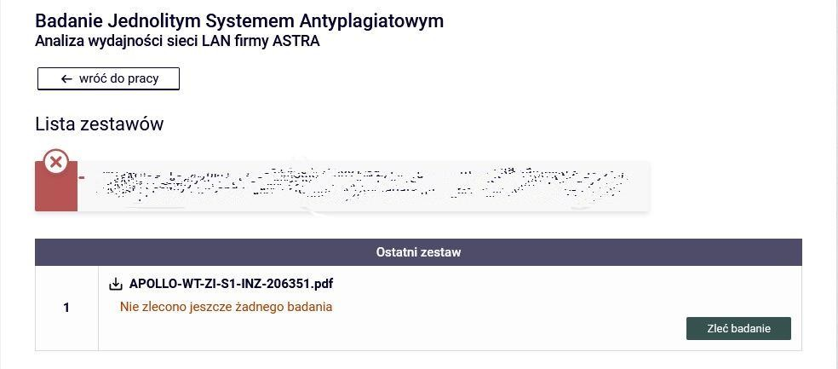

  - The thesis verification procedure can take up to several hours. The status of the verification can be checked in the system (Fig. below). A detailed procedure for the verification and acceptance of papers in the JSA is provided in Appendix 2. to the Procedure of Remote Diploma Thesis Defense. After the completion of the verification, the Supervisor receives an e-mail message to the university's employee account informing them of its completion.

PLEASE NOTE: This notification will be sent by the JSA system to the email address provided during the Supervisor's registration with JSA.
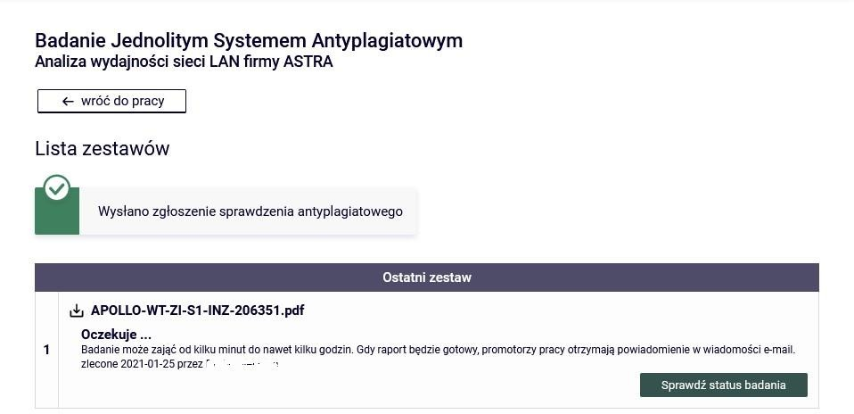

  - Once the JSA has completed the verification, the thesis test report is available in the APD system.

  - After completing the verification by JSA, the supervisor reads the report of the thesis verification, and then:
- if the result obtained is sufficient, he/she accepts the report from the JSA system (fig. below).
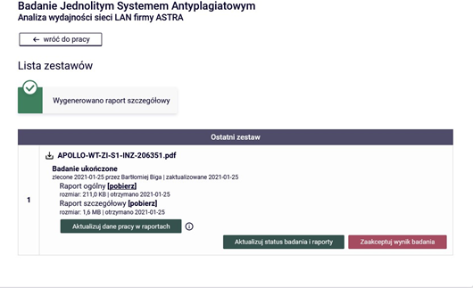

- if the result obtained is not sufficient, and he/she believes that it requires improvement on the part of the Student, he/she clicks on the "Submit for improvement" button and thus sends the thesis back to the Student for improvement. Then the thesis returns to step "2. Uploading thesis files" in the APD system, and the Procedure of remote defense of the diploma thesis begins with point 1.4.

- In some cases, when the similarity coefficient is high due to the inclusion of a large number of citations of other works or documents in the work (e.g. legal acts) – may be necessary for the Supervisor to intervene by logging directly into the JSA system (https://jsa.opi.org.pl/) and excluding these fragments from the analysis and then recalculating the similarity coefficients (in the JSA system). However, it should be remembered that this is only possible before the verification results are accepted . Once the Supervisor has completed the JSA steps, he/she downloads the updated report in the APD system by clicking on the "Update thesis test and reports" button.
In the case referred to above, when the similarity coefficient is greater than recommended (40% - cf. Appendix 2 to the Procedure for Remote Diploma Thesis Defense), the Supervisor is obliged to fill in the tab under the JSA report: "Applications, Supervisor (advisor) applies for".

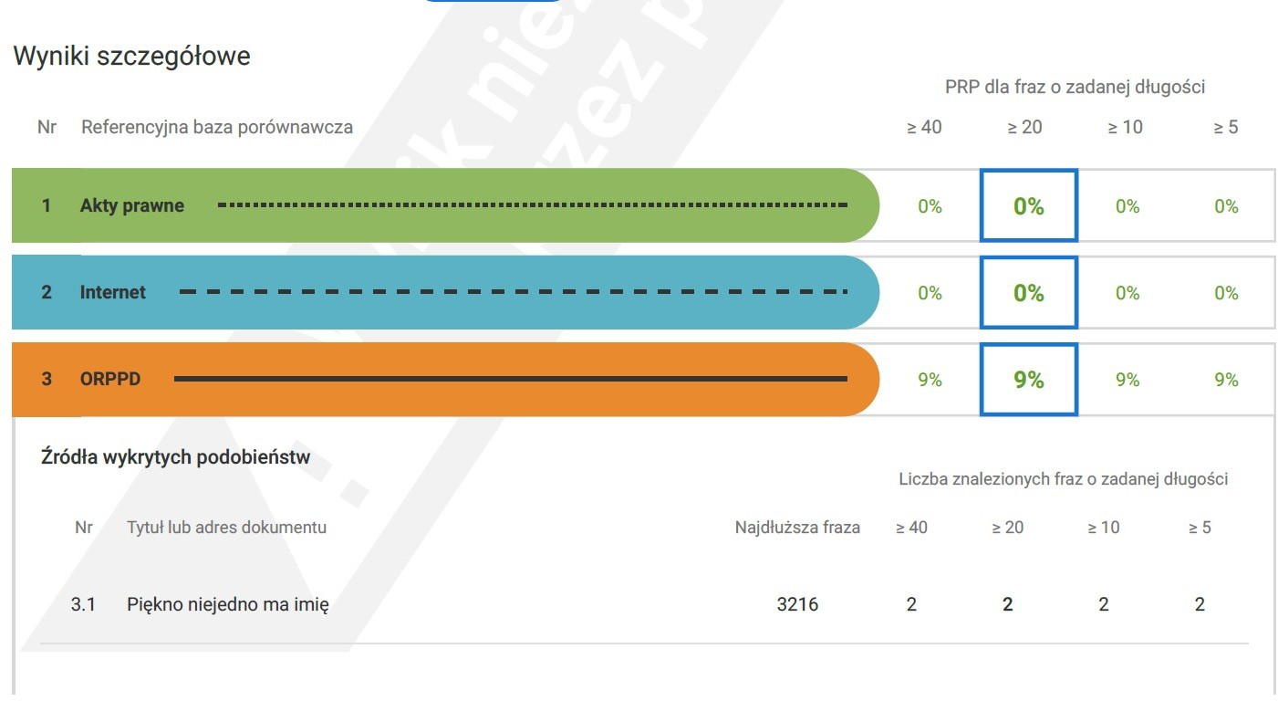

The supervisor is also obliged to justify why, despite the values exceeding the recommended indicator of 40%, he allows work to be defensed. To this end, in the "Remarks" field, he/she justifies his position in relation to those areas for which the JSA report indicated values exceeding 40% and, after filling in this field, finally chooses one of the options, i.e. allows the thesis to progress to the defense or does not allow the thesis for defense.

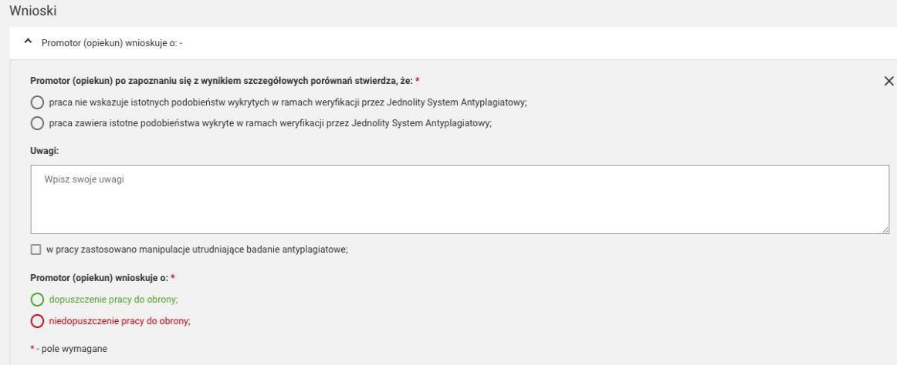

The diploma thesis is considered to have been submitted within the deadline after meeting the following conditions:
- passing all classes covered by the study program, including the diploma seminar;
- entering the written diploma thesis into the APD system by the student;
- verification of the written diploma thesis by the Supervisor using the Uniform Anti-Plagiarism System, confirmed in the APD system with the annotation "I accept", constituting the acceptance of the final version of the diploma thesis.
Passing the diploma seminar takes place after the final acceptance of the diploma thesis, in accordance with point 3 above.

  - The Supervisor informs about the accepted antiplagiarism General Report in the JSA and proposes the Reviewer by contacting the Student Service Center by phone or sending an e-mail to the Employee of the Student Service Center.

  - After the student submits a statement of readiness to defend himself, the employee of the Student Service Center creates and launches the Circular (final clearance) in the USOSweb system (Appendix 1 to the Procedure for Remote Diploma Thesis Defense).

Note: The student should, via the Final Clearance document, obtain a settlement with all departments at the University, i.e. the Main Library, the Student and PhD Student Settlements Department and the student dormitory.

  - The student without undue delay downloads and fills in the form available in the USOSweb system: Statement of readiness to defend the diploma thesis (Appendix 4 to the Procedure for remote defense of the diploma thesis), including the necessary additions with:
- Supplementary Information for the Diploma Supplement
- Statement regarding the processing of the Graduate's personal data
- Information for Graduates on the processing of personal data
- Application for a copy of the diploma/supplement in a foreign language (optional)

At this stage, the above-mentioned documents are sent via the USOS system.

Submitting applications is available after logging in to the USOSweb system in the menu
"FOR STUDENTS -> APPLICATIONS -> Submit a new application."

The Student delivers to the unit serving the Students on the day of the defense of the diploma thesis:
- printed and signed: the originals of the Statement on the Use of Artificial Intelligence Appendix 3 and the originals of the documents forming Appendix 4 to the Diploma Thesis Defense Procedure;
- downloaded from the APD system:
- general report on the JSA verification
- worksheet (Appendix 5 to the Diploma Thesis Defense Procedure)
- a statement on making the thesis available (Appendix 6 to the Diploma Thesis Defense Procedure).

  - An employee of Student Service Center presents the Director of the Institute with the Reviewer's proposal, who accepts it or indicates another person. Then enters a response to the Statement of Readiness to Defend the Diploma Thesis submitted by the Student, enters the Reviewer into the USOS system. An employee of the Student Service Center informs the Supervisor about the positive consideration of the statement submitted by the Student and the appointment of a Reviewer.

In the USOS system, "Students" - > "Diplomas" - > "Diploma theses by person", then the "Details" tab (for entering the date) and the "Reviews" tab (for entering the Reviewer).
  - An employee who has been appointed as a Reviewer is visible to the Student
in the APD system.

  - The promoter in the APD system clicks on the "Submit to enter a review" button and proceeds to step "4. Issuing reviews".

  - The Supervisor and the Reviewer enter and approve the content of the review in the APD system – Fig. below. The content of the approved review is visible to the Student. An employee of Student Service Center prints reviews and puts them in the Student's file.

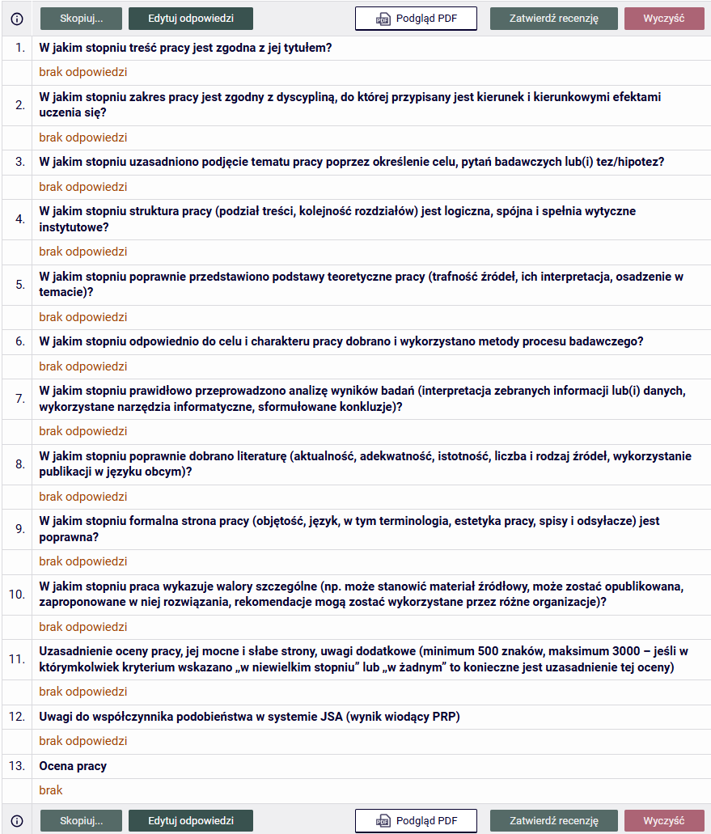

  - After the review is approved by the Supervisor and the Reviewer, the system proceeds to step "5. Work ready to defend".

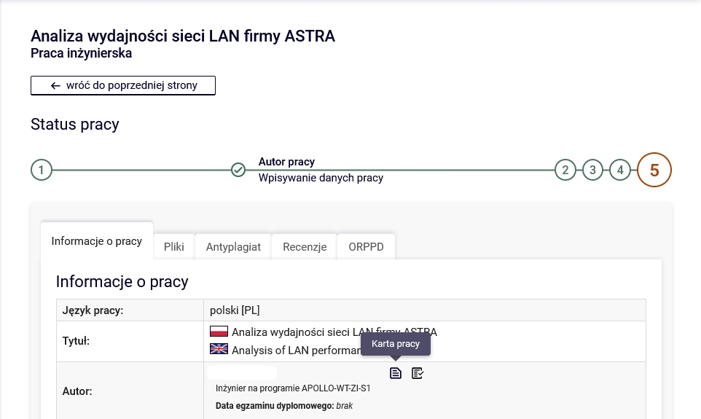

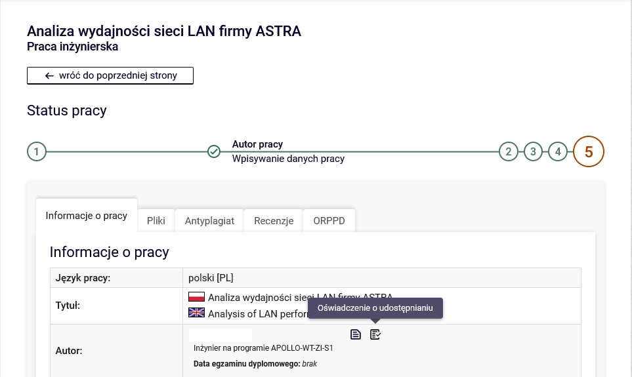
1.17 An employee of Student Service Center checks the Circular (clearance form) and if the Student meets all the conditions required for admission to the defense, approves the Clearance form
1.18. In the period designated for conducting defenses, i.e. from January and June each year, an employee of the Student Service Center agrees with the Chairperson of the Diploma Examination Commission on possible dates of defenses. Then, on the basis of the indicated dates, agrees with the Supervisor the schedule of defenses of individual Students ready to take the diploma exam.
An employee of the Student Service Center notifies the Chairperson, Supervisor, Reviewer and Member (in a situation where he/she replaces the Reviewer in the Commission) of the agreed date of defense.

- Remote diploma exam

The remote diploma exam can only be conducted using the Microsoft Teams platform and using the work email accounts of Employees located in the uek.krakow.pl domain and the email accounts of Students located in the student.uek.krakow.pl domain.

  - The prerequisites for conducting the remote diploma exam are:
    - the Student meets all the requirements set out in Chapter 6.
Regulations of studies at the Krakow University of Economics,
    - access of the Student and Members of the Diploma Examination Commission (Chairperson of the Commission, Supervisor and Reviewer, and Member, in a situation where he/she replaces the Reviewer in the Commission) to a computer equipped with a microphone and a camera and a stable Internet connection;

Note: Members of the Commission should check the technical condition of computers and Internet access before the exam;

- A student may use a mobile phone during the diploma exam only with the consent of the Chairman of the Commission;

- When taking the exam, the student should log in using the created university email account.

- The student is obliged to take the remote diploma exam in appropriate clothing, in accordance with academic customs, during the defense of the diploma thesis.

  - At least 7 days before the scheduled date of the remote diploma exam, the Employee of Student Service Center, after prior arrangement, sends to the e-mail accounts of the Student and the Members of the Diploma Examination Commission (i.e. the Chairman, Supervisor, Reviewer and Member, in a situation where he/she replaces the Reviewer in the Commission) information about the date, time of the diploma exam and the designated room in which the exam will take place. An employee of Student Service Center sends a list of persons taking the diploma exam on a given day to the Chairman of the Diploma Examination Commission in the text of the message
  - An employee of Student Service Center prepares the system for the Student's diploma exam.

On the form "Students" - > "Diplomas" - > "Diplomas and exams":

    - in the "Exams" tab, verifies the "Diploma Issuing Unit", "Degree Code", enters the date and time of the exam, ticks the "Is the exam remote" option and ticks the option "Is the protocol in APD" (fig. below),
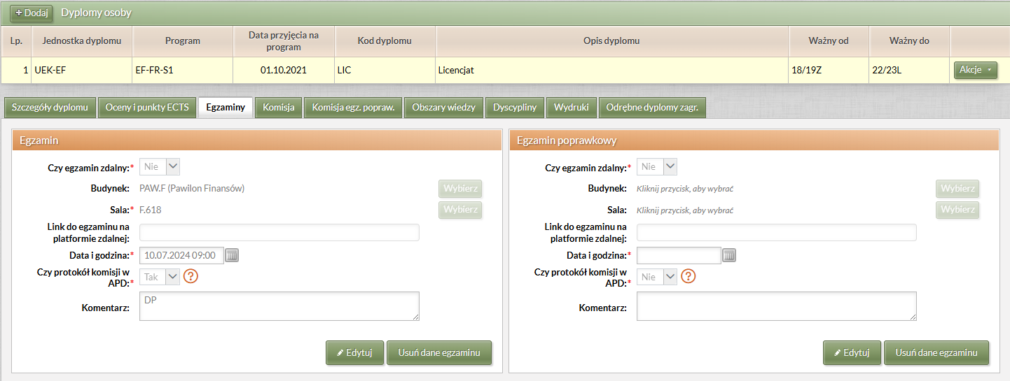

    - in the "Grades and ECTS credits" tab, enter the "average of studies" (the value can be entered manually or calculated using the form available after clicking on the "Calculate grade average" button) (fig. below),

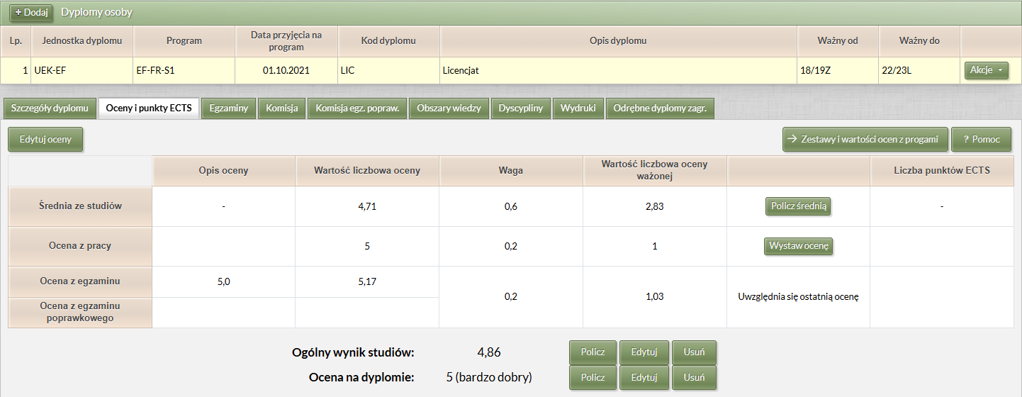

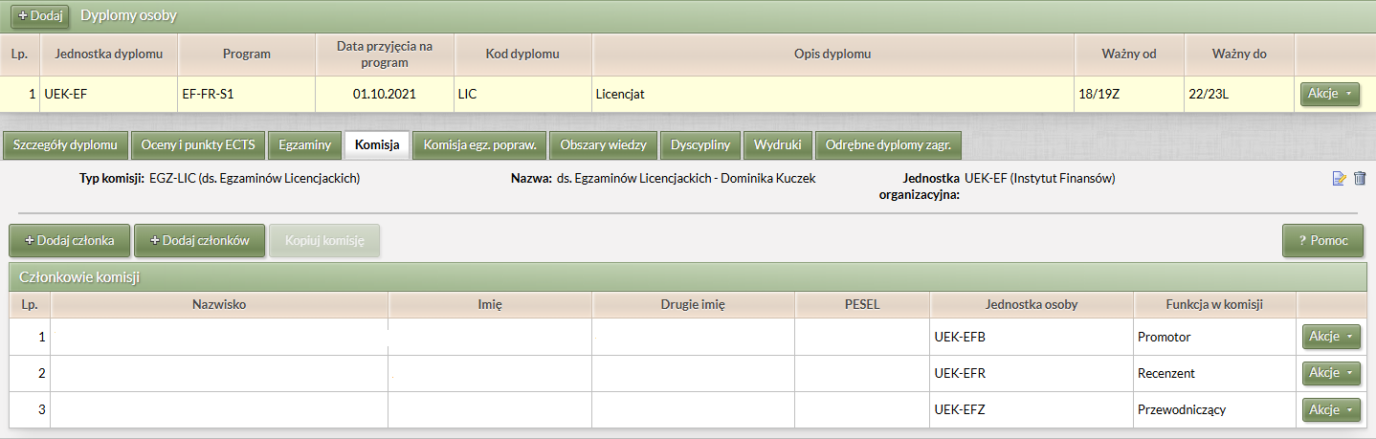
    - in the "Commission" tab, enters the composition of the Diploma Examination Commission and determines the functions of its individual members (it is possible to copy the composition of the Commission from one exam to another). (Fig. below)

  - After preparation system by the Employee of Student Service Center, the Chairperson and Members of the Commission may fill in the protocol remotely in the APD system:

    - in the "MY APD" section, information about upcoming exams appears (fig. below),

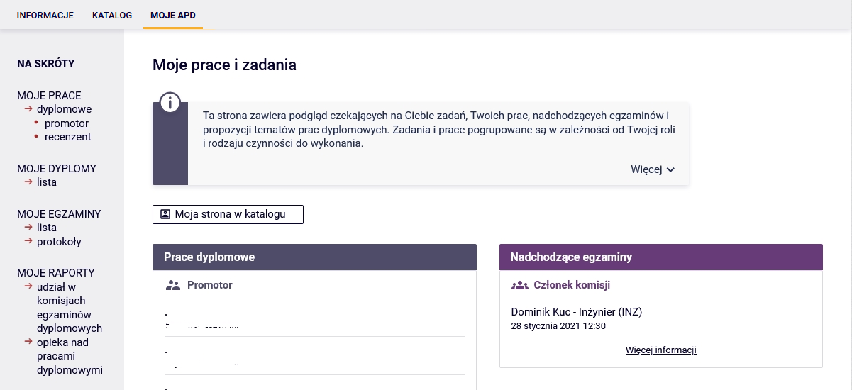

    - Click on the "More information" link to see the exam details (Fig. below),
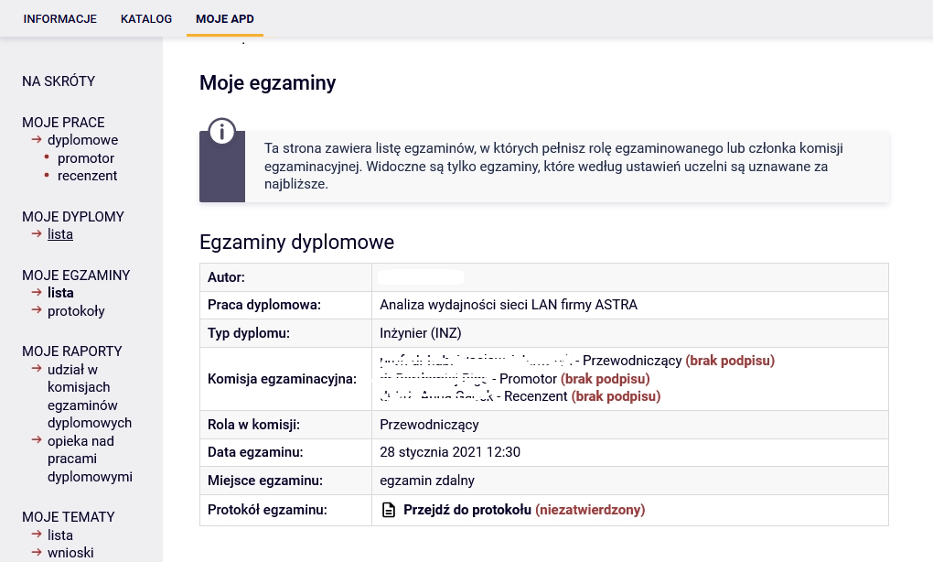

    - after clicking on the title of the thesis, access to the protocol appears - the link "Exam protocol" (fig. below),

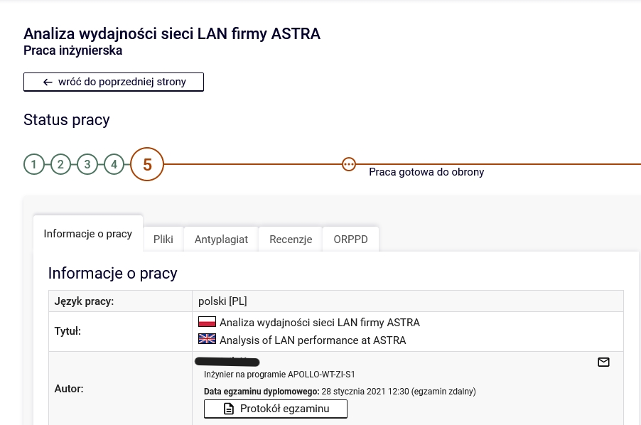

  - Before the exam date, the Chairperson of the Commission must create a protocol in the APD system by clicking on the "Create Protocol" button (Fig. below).
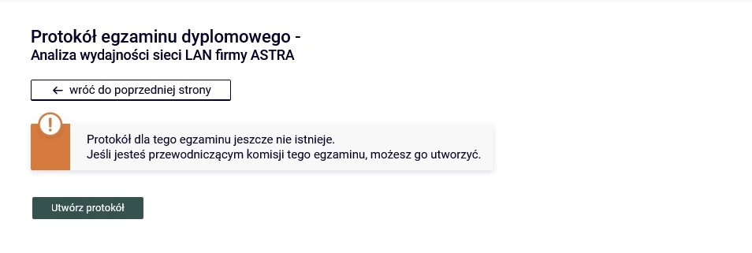

  - Then, the Chairman of the Commission or an employee authorized by the Director of the Institute immediately sets up a meeting and sends an invitation to the Commission Members and the Student.

  - On the exam date (date, time), the person setting up the Microsoft Teams meeting starts an online session, at which the Student and all Members of the Diploma Exam Commission should be present five minutes before the scheduled start date.

  - During the exam, the cameras and microphones of all persons participating in the exam (the Student and the Members of the Diploma Examination Commission) must be turned on. For the purpose of verification, the student presents his/her student ID. A student taking the diploma exam should sit in front of the camera and be clearly visible to the Commission during the exam. The student should take care of a calm and quiet room for the duration of the online broadcast. During the exam, the Student provides his/her computer desktop, which is the only screen available to the Student during the exam.
To do this, the Student clicks on the "Share" button and then selects the option
"Share Screen."

  - Immediately before the exam, the Chairman of the Commission opens the previously created protocol in the APD system and starts the exam by clicking on the "Start exam" button (fig. below).

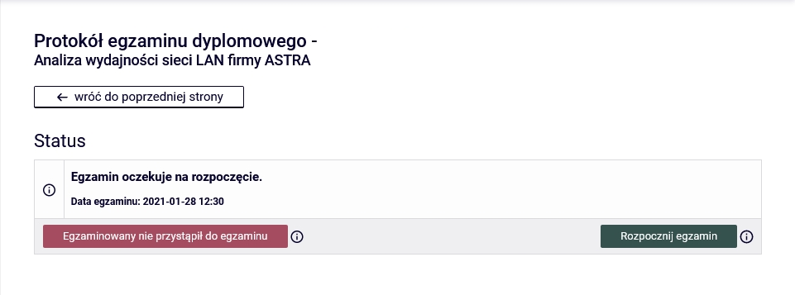
Note: All Members have the ability to view the protocol.

  - The diploma exam begins with the drawing of the first question or the first question being asked by the Supervisor. The promoter posts his question in the chat by clicking on the "Chat" icon. This is followed by the Student's answer to the question and a discussion led by the Supervisor. With the second and third questions, respectively, the situation repeats itself. Additional questions may be asked by all Members of the Diploma Examination Commission (Chairperson, Supervisor, Reviewer and Member, in a situation where he/she replaces the Reviewer in the Commission). If the Student's answers require a written, graphic or presentation of photos and drawings, the student can edit them in the appropriate program

(word processor, spreadsheet, graphics program, etc.) and present it on your desktop.
Note: in the case of diploma exams on the degree program of Spatial Management, when presenting the diploma thesis, the Student provides a synthetic board on the desktop presenting the idea of the work or selected drawings, which are part of the diploma project and explain the concept and/or elements of the work. It is advisable to prepare for presentation on the desktop all drawings that are elements of the diploma project.
  - The diploma exam is completed by the Chairman of the Diploma Examination Commission, who is obliged to complete the diploma exam protocol in the APD system:
    - adding questions is possible by clicking on the "Add a question" button (fig. below),
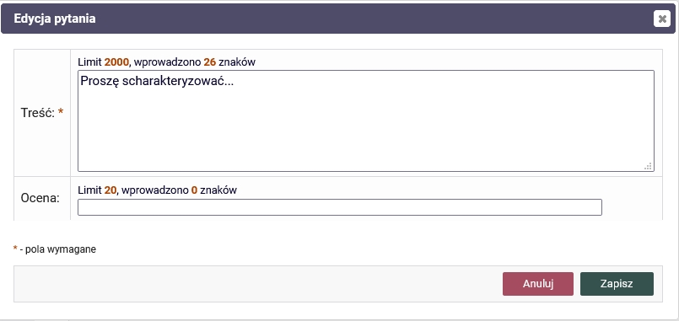

    - the answer to each question should be assessed immediately (fig. below),

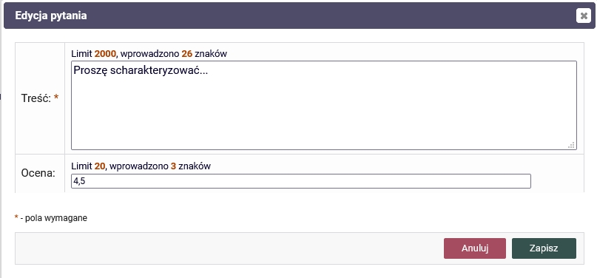

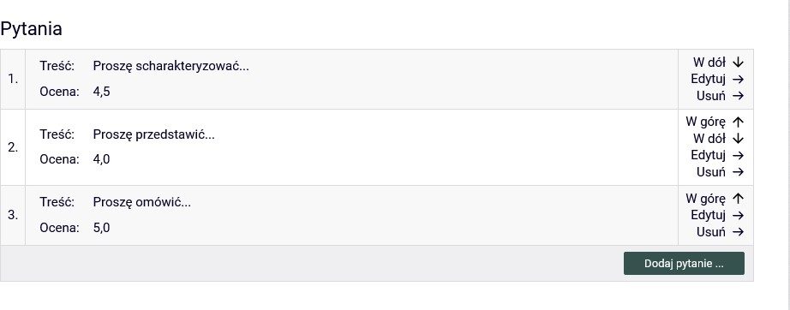
    - a list of questions with grades from the answers is available on the form (fig. below),

  - In the event of interruption of the transmission of the course of the remote diploma exam, an attempt to reconnect is made, which is carried out by the person setting up the meeting. If the reconnection is successful, the student draws or receives a new question. In the event of another interruption of the transmission of the distance diploma exam or the occurrence of other unforeseen factors, an additional date of the exam is set no earlier than after 7 days.
  - After the diploma exam, the session with the Student ends. The student is asked by the Chairman of the Commission to temporarily leave the meeting. is removed from the meeting.

To do this, click on the "More options" button located under the three-dot icon next to the Student's name and select the "Remove from meeting" option.

After conducting the diploma exam, the Commission determines the grade from the diploma exam during the classified part of the exam, and in the case of a positive result of the exam, also the final result of studies.
The Chairman of the Diploma Examination Commission, add the following fields in the diploma exam protocol in the APD system:

    - after entering all the questions and grades from the answers, fill in the "Job grade" by clicking on the "Edit grades" button (fig. below),

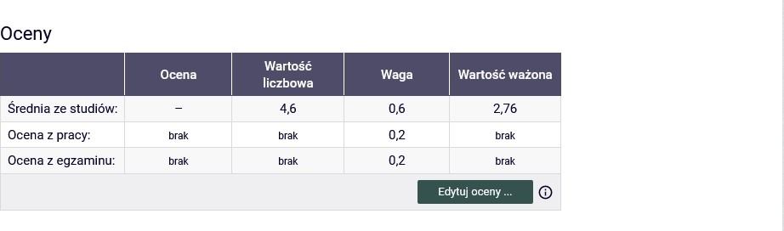
If you are calculating a rating from a review, you can use the "Leave a rating" button
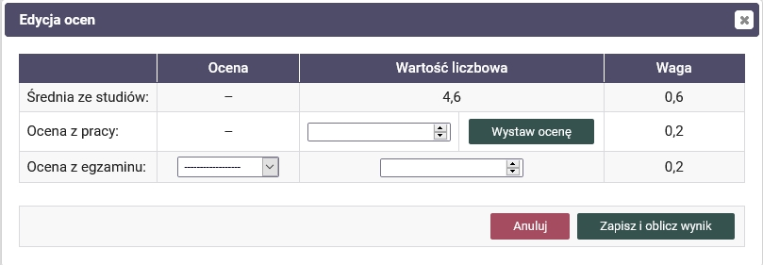
which will allow for automatic calculation of the average of the reviewers' ratings.

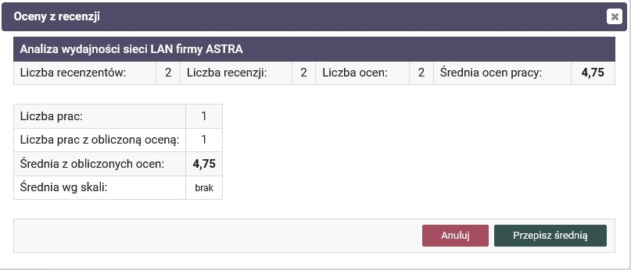

    - then, in a similar way, the "Exam Grade", calculated in accordance with § 47 section 8 of the Regulations of Studies at the Krakow University of Economics, should be completed by selecting the appropriate value from the drop-down list (Fig. below),
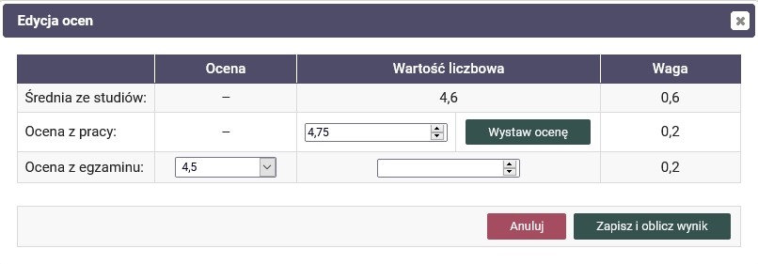

You need to fill in the fields: "Rating" and "Numeric value".

    - after entering all grades, the "Grade on the diploma" is calculated and it is possible to approve the protocol (fig. below),
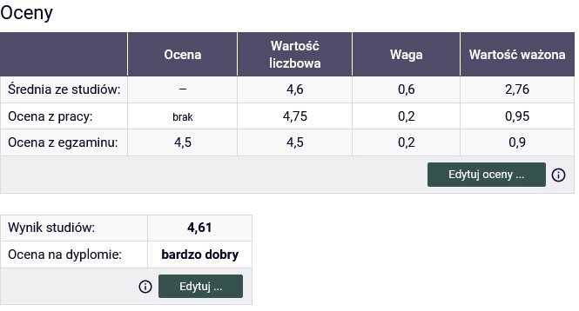
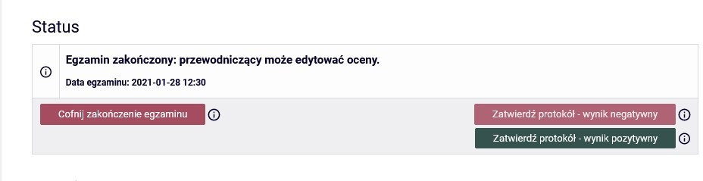

    - after the approval of the minutes, the President signs the minutes (protocol). Then the minutes are signed by the other Members of the Commission (Fig. below),
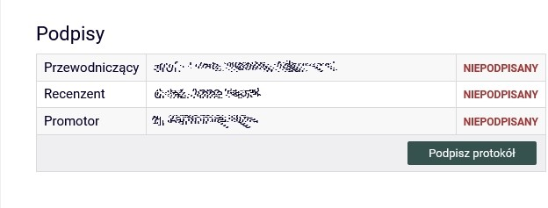

Note: in a situation where the Examination Commission decides to change the grade, in accordance with §48, section 8 of the Regulations of Studies at the Krakow University of Economics (fig. below).

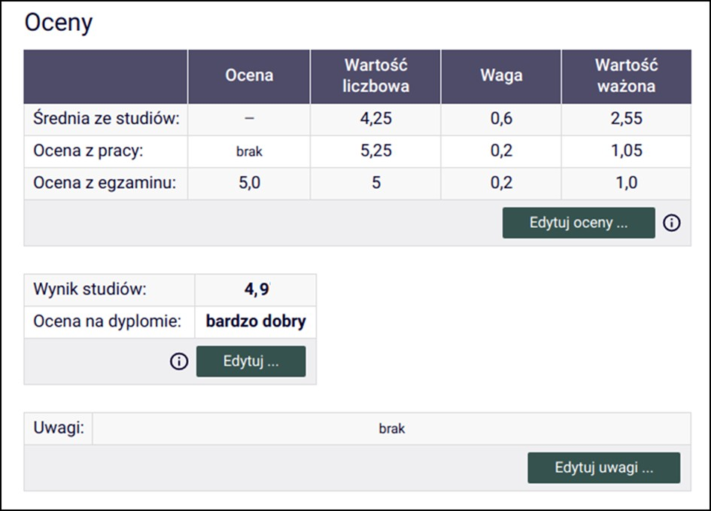

The Chairperson of the Commission corrects the result of the studies by clicking on the "Edit" button and selecting the appropriate grade from the drop-down list (Fig. below).
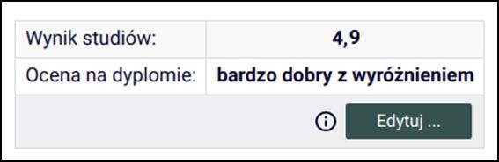

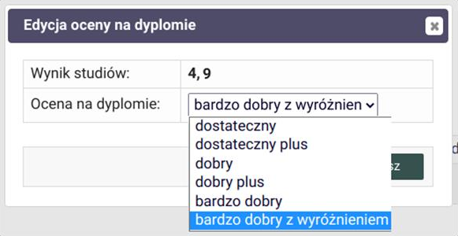

Then, the Chairperson of the Commission enters an appropriate annotation in the "Comments" field (Fig. below).

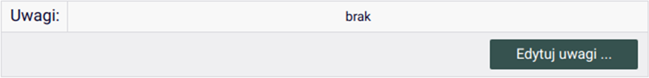
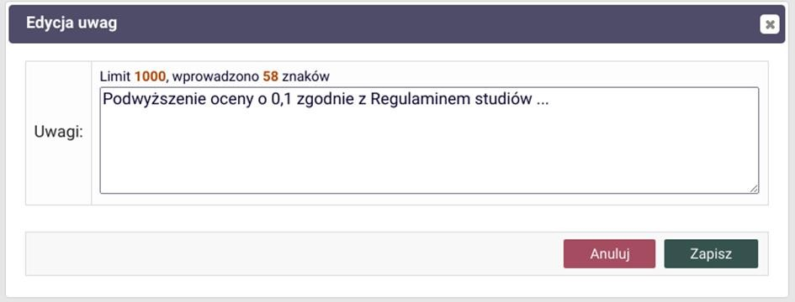

After the amendments are introduced, the Chairperson of the Commission approves and signs the minutes.
Then the minutes (protocol) are signed by the other Members of the Commission.

  - Immediately after the completion of the remote diploma exam, the Chairperson and all Members of the Commission sign the protocol electronically in the APD system. Then the Chairman clicks on the "End Exam" button.

2.15. The Chairperson of the Commission again invites the Student to a session with the Diploma Examination Commission.

To do this, using the "People" icon, displaying the "Suggestions" area, click the "Request to join" button next to the Student's name.

The Chairperson of the Commission announces the result of the diploma examination determined by the Commission. In the event of a positive result of the diploma examination, the Chairperson of the Commission also announces the final result of studies and announces the decision on awarding the appropriate professional title.

  - After the defense is completed, the Employee of Student Service Center downloads the Remote Diploma Exam Protocol from the APD system and puts it in the Student's file.

  - When receiving the student's diploma in the case of second-cycle studies, the student submits the student ID card to the Student Service Center.

  - An employee of Student Service Center closes the Circular Card, confirming the receipt of the diploma of graduation by the Student.

  - In the event of obtaining an unsatisfactory grade in the diploma exam or unjustified failure to take this exam within the set deadline, the Director of the Institute sets the second date of the exam as the final one. The re-exam may not take place earlier than one month and must take place no later than three months after the date of the first exam. Failure to pass the diploma exam on the second date results in deletion from the list of students, on the basis of § 36 section 1 point 4 of the Study Regulations at the Krakow University of Economics. The Commission's decision is recorded in the protocol in the "Comments" field and by the Employee of Student Service Center in the USOS system in the "Comment" field (until the first date of the exam).
- If it is necessary to conduct a retake exam, we start the procedure from point 2. Diploma exam. The procedure is initiated by the Employee of the Student Service Center with entries in the USOS system in the fields: "Date and time of the retake exam", "Retake exam Commission". Additionally, and ticks the "Is protocol in APD" checkbox.

List of attachments to the Remote Diploma Thesis Defense Procedure:

Appendix 1. Creating and operating the Circular (clearance form) – filled in by an Employee of Student Service Center
Appendix 2. Procedure for sending a diploma thesis for examination in the JSA system and acceptance of the examination report
Appendix 3. Statement on the use of artificial intelligence
Appendix 4. Statement of readiness to defend the diploma thesis (with attachments 4a-4d) – to be filled in by the Student
Appendix 5. Diploma Thesis Card – to be filled in by the Student
Appendix 6. Statement on making the work available – to be filled in by the Student

If you experience technical problems, you can get help from:

- JSA system – uasa@uek.krakow.pl
- APD system – tel. (12) 293-58-25, email: apd-pomoc@uek.krakow.pl
- circulation – tel. (12) 293-58-25, email: usosweb@uek.krakow.pl
Appendix 1. to the Diploma Thesis Defense Procedure

Creating and maintaining the Circular (clearance form)

- Issuing a circular slip to the Student is possible in the USOSweb system. After logging in and going to the "FOR EVERYONE" tab, select the Circular option, and then "issue a new circular ticket".
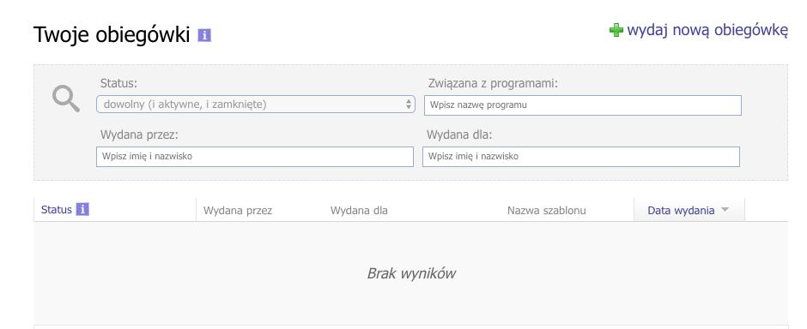

- In the displayed form, we indicate the circular (consistent with the name of the Employee of the Student Service Center ), select the Student and the degree to which the circular (clearance form) relates.

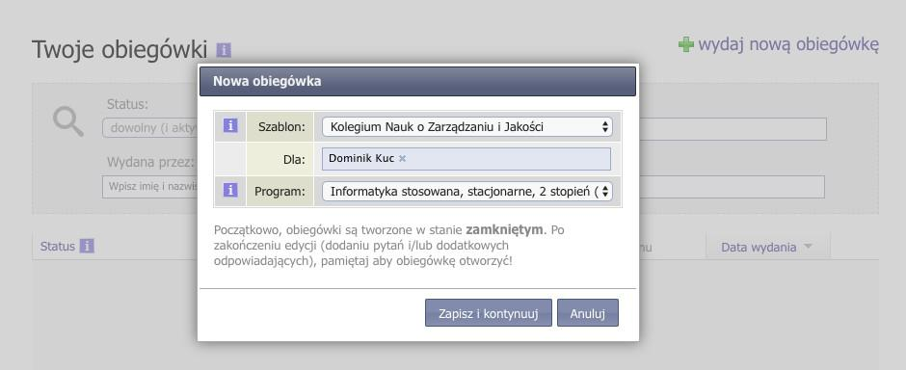

- Click on "Save and continue". After doing this, we will move on to the detailed data of the circular.

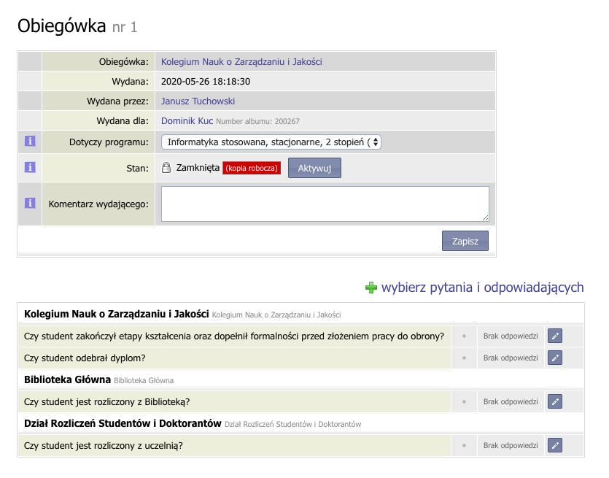

- The created circular contains a set of questions addressed to various departments of the University. To activate it, press the "Activate" button. The active circular allows the Employees of the Student Service Center to answer two questions ("Has the Student completed the stages of education and completed the formalities before submitting the thesis for defense?" and "Has the Student received the diploma?"). The remaining questions are answered by people from the mentioned departments. Some Students may also be asked about settling accounts with a student dormitory (if they were registered there). Below is a view of the active circular.

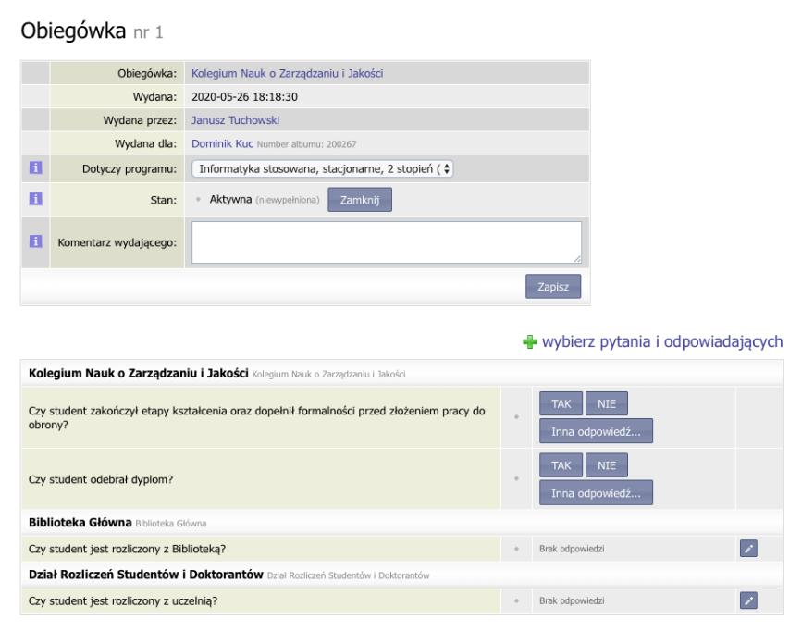

- Department employees assigned to individual questions receive email notifications asking them to provide an answer (YES, NO or another answer). To answer, they log in to the USOSweb system, go to the "FOR EVERYONE" tab, select "Circulars" and indicate a specific circular. After providing the answer, it is visible to both the Student and the people who issued the circular. Below is an example of filling in the circular form by the Library and the Department of Student and Doctoral Student Settlements.

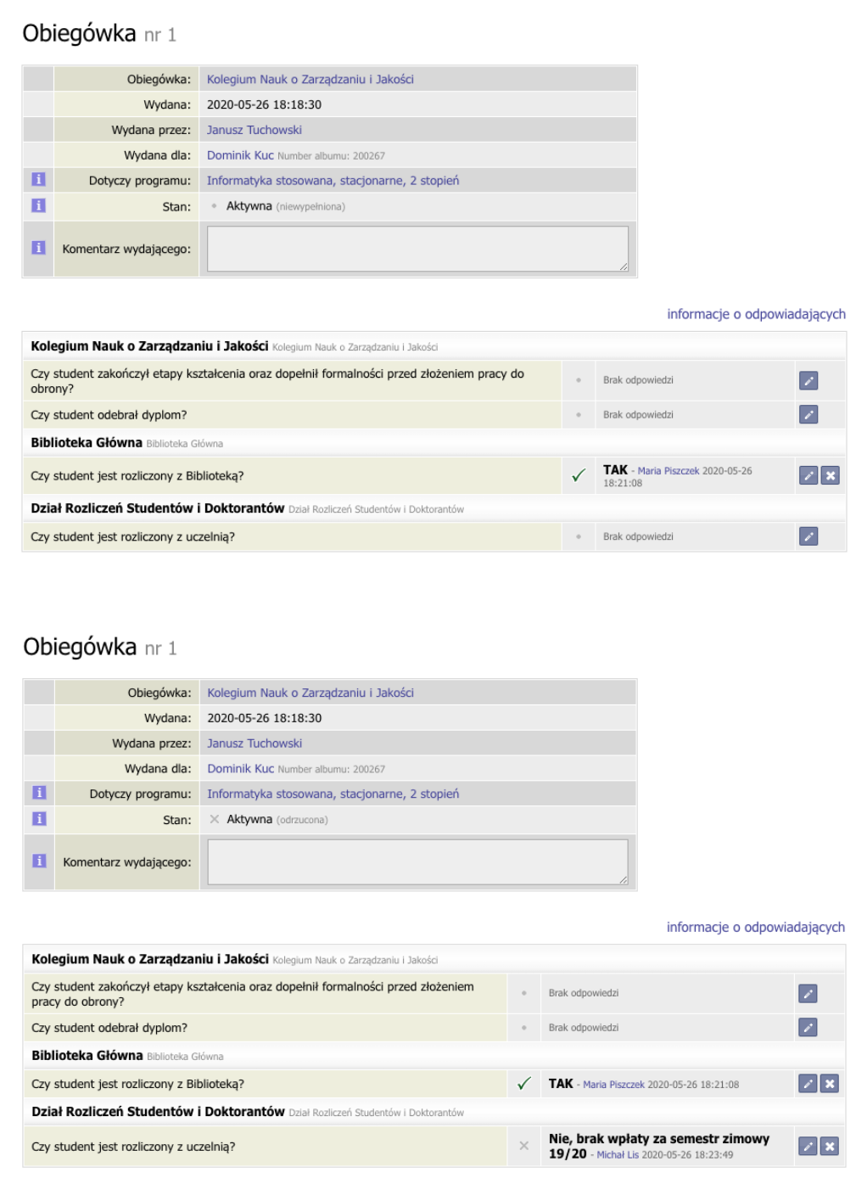

- In the case of a larger number of circulars, the employee of a given department, instead of clicking on each one, can use the search engine or start a serial reply.
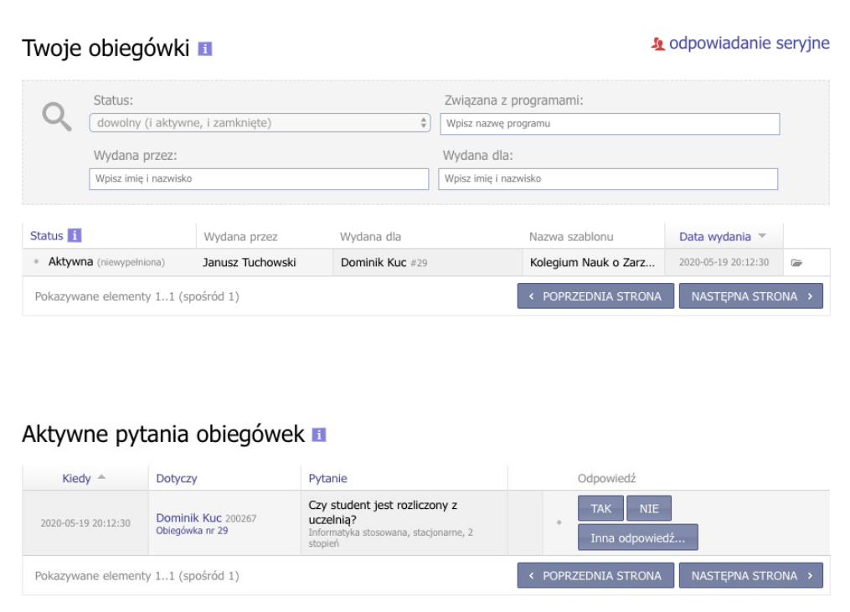

- If all the answers in the circular are positive and the formalities related to submitting the thesis for defense have been met, the employee of the Student Service Center issuing the circular provides an answer to the question: "Has the Student completed the stages of education and completed the formalities before submitting the thesis for defense?"
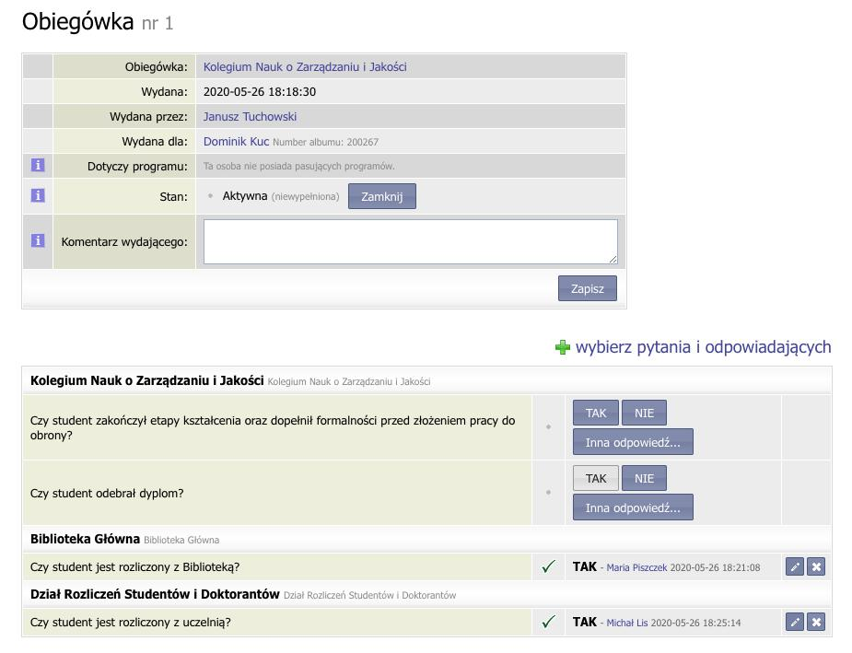

- After the defense, upon receipt of the diploma, the Employee of Student Service Center issuing the circular answers the question: "Has the Student received the diploma?". Then the completed circulation should be closed by using the "Close" button.

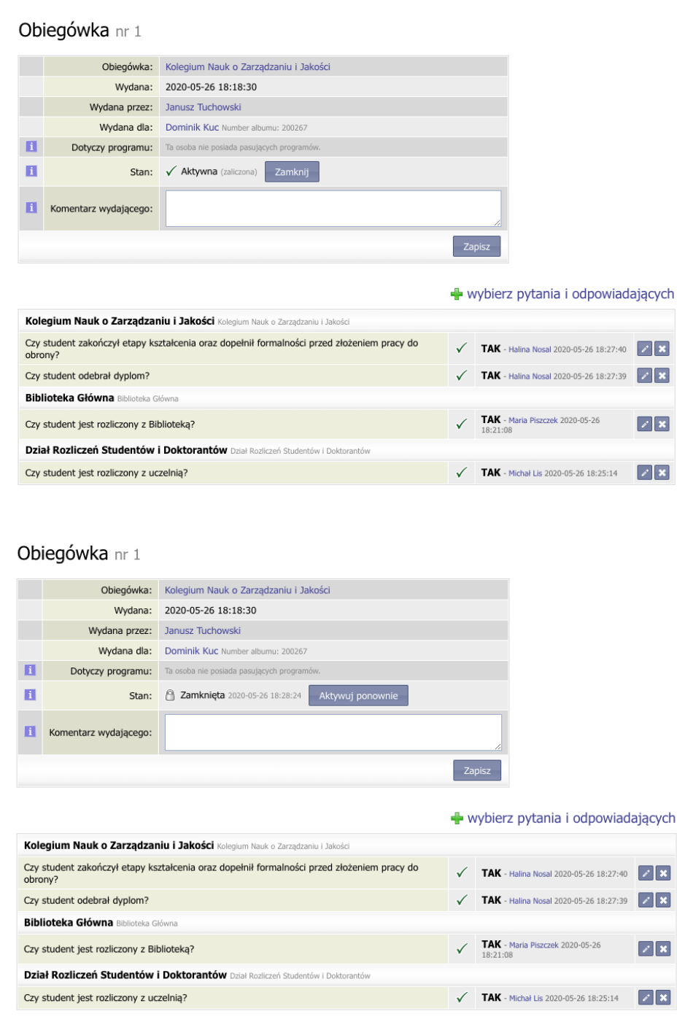

- After opening the circular and during the entire process of completing it, the Student has a preview of which of the departments gave the answer. They can also check who should answer a particular question by clicking on "Answerer information."

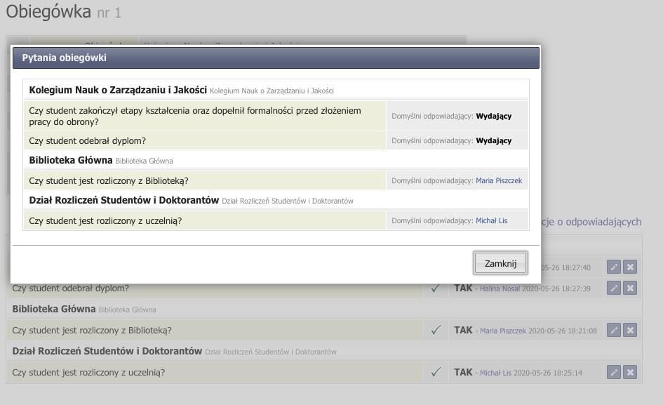

Appendix 2. to the Diploma Thesis Defense Procedure

Procedure for sending a diploma thesis for examination in the JSA system and acceptance of the examination report

1.1. The order for the analysis of the diploma thesis in the JSA (Jednolity System Antyplagiatowy - Uniform Anti-Plagiarism System) system should be made from the APD account. This process is carried out in step 3 of the Diploma Thesis Defense Procedure – see point 1.5 and by clicking the "Manage a test" button. From this level, the Supervisor can send the work for study at JSA. This step initiates the process of anti-plagiarism analysis, the final result of which is the generation of two reports on this activity. One of them is a general report, and the other is a detailed report (generated after ordering by the Supervisor). Both are available in the APD system.

1.2. Notwithstanding the above procedure described in point 1, the Supervisor also has the possibility of accessing the results of the anti-plagiarism analysis from the JSA system available at: https://jsa.opi.org.pl/, which can always be used.
Please note that the process must be initiated in the APD system beforehand.

1.3. Supervisor accounts in the JSA system are created by the JSA Administrator successively at the moment of receiving the privilege of promoting the diploma thesis. It is not possible to register for the system on your own. Access to the JSA system is authorized by KUE or by another university that has previously registered the Supervisor.

1.4.Za Submitting a JSA account sends an appropriate e-mail to the university's user account, which contains a confirmation of actions, information about who the Administrator is and who created the account for the user, and an activation link. The Supervisor account must be activated. To do this, the user must click on the ACTIVATE ACCOUNT button and assign a password to their account according to the criteria set by the JSA.

1.5.The JSA account activation process (described above – point 1.4) is carried out only once. Access to the account is done by providing the login and password received during the activation process.

1.6. After logging in to the Uniform Anti-Plagiarism System, the Supervisor has the opportunity to view the work of his/her protégé and access the results of the anti-plagiarism analysis report. The results of the analysis are available in the RESEARCH menu, and then - choosing the title of the diploma thesis - click on the REPORT button. In this way, access to the analysis statistics along with the results of the similarities of the indicated fragments of the diploma thesis text, divided according to four reference comparative databases, is obtained.
Detailed information on how to view the results of the analysis report, interpret the results, re-analyze the thesis can be found in the knowledge base, in
e-learning courses and in the instructional videos available on the https://jsa.opi.org.pl/centrum-pomocy/baza-wiedzy/ website

2.1. The results from the thesis check (reports) are available to the Supervisor in both the JSA and APD systems. On the other hand, the Student has access to the content of similarity reports only in the APD system. From the level of the APD system, the Reviewer also has access to these reports.

2.2. The supervisor reads the detailed report obtained from the system and on this basis makes a decision on whether to allow the work to be used for defense or whether it is necessary to improve the work.

2.3.No limit values of similarity coefficients shall be set for Supervisors. By analyzing the similarity reports, the Supervisor makes an individual assessment of the originality and independence of the work, taking into account, m.in, the purpose and nature of the work, the number and type of sources used in the work, the manner and context of the use of these sources, etc.

2.4.For JSA, the recommended coefficient values remain unchanged at 40%, provided that:

- the value of the similarity coefficient 1 – Database of Legal Acts – exceeds 40%,
- or the value of the similarity coefficient 2 – the Internet database – exceeds the level of 40%,
-or the value of the similarity coefficient 3 – the ORPPD base – exceeds the level of 40%,
- or the value of the similarity coefficient 4 – the institution's base – exceeds 40%,

and in the opinion of the Supervisor the diploma thesis is an independent work, the Supervisor is obliged to fill in the tab: "Applications" The Supervisor (advisor) requests for:"

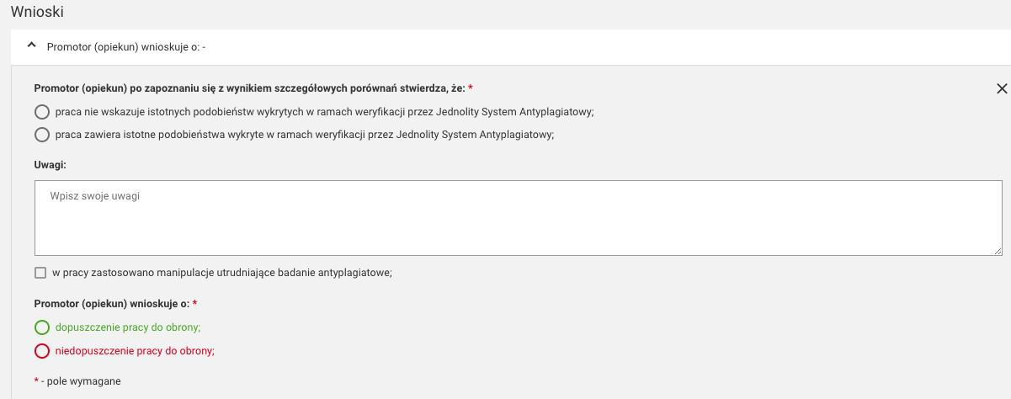

In the "Comments" field, the Supervisor justifies why he/she admits or rejects the work for the defense by referring to those fields/areas in which the similarity rates have exceeded 40%, i.e. the Legal Acts Database, and/or the Internet database, and/or the ORPPD database and/or the institution database.

Finally, the Supervisor confirms his decision by clicking on one of two options:

- allowing work for the defense,
- not allowing work to defend themselves.

The values of the similarity coefficients in the JSA system are displayed in specific colors: green, orange and red.

Green indicates that the paper was written by the Student, orange indicates that the Supervisor should pay attention to the details of the JSA report. In such a work, there may be some phrases borrowed from another work, but there are not many of them. The value of the coefficient in red indicates that the Supervisor should absolutely review the JSA report, because the work may or may not - for example, legal acts - contain a lot of phrases taken from other sources.
In each situation, the Supervisor ultimately decides whether to allow the work to be defended.

2.5.Depending on the subject matter of diploma theses in various fields, e.g. engineering or economics, the content of the thesis may contain numerous quotations, e.g. taken from the Database of Legal Acts. This, in turn, may result in high values of similarity coefficients, exceeding the standard threshold values set out in point 2.4. of the Procedures for sending the diploma thesis for examination in the JSA system and acceptance of the examination report. It is possible to lower them by the so-called exclusion of fragments of text and recalculation of the result. This operation can be performed by the Supervisor in their JSA account, by marking the mentioned citations for the appropriate reference base and excluding the fragment (with the reason for exclusion) from the similarity analysis process. Clicking the RECALCULATE RESULTS button will recalculate and decrease the similarity coefficients values. Details of the procedure are presented in the knowledge base on the JSA website: https://jsa.opi.org.pl/centrum-pomocy/baza-wiedzy/przeliczanie_wyniku/

Exclusion of a fragment of texts is possible only if the Supervisor has not yet accepted the work in JSA, i.e. in the general report from the analysis, a white triangle in an orange circle is displayed in the upper right corner, and an orange exclamation mark is displayed in the middle of the triangle. The whole is accompanied by a comment in the form of: Result not accepted by the Supervisor.

Acceptance of the work by the Supervisor is the final activity of the anti-plagiarism analysis process in the JSA system and later it is not possible to undo/change any options and results of the analysis.

Thesis acceptance means that a checkbox in a green circle is displayed in the upper right corner of the general report. Next to it is a comment in the form of Result accepted by the Supervisor.

2.6. In each situation, the Supervisor ultimately decides whether to allow the work to be defended. However, he accepts the report in the JSA system beforehand.

3. If it is necessary to improve the work, the Student makes the necessary corrections to the text of the work, uploads the work to the APD system and after obtaining the Supervisor's approval, the work is sent again for analysis.

4. In the case of admission to the defense of a work for which the similarity coefficients have exceeded the levels indicated in point 2.4. of the Procedures for sending the diploma thesis for examination in the JSA system and acceptance of the examination report, the Supervisor accepts the report from the JSA system.

5.1. In the APD system, in step 4 Review in the Diploma Thesis Evaluation tab, in point 12 Remarks on the similarity coefficient in the JSA system (leading score), the Supervisor and the Reviewer of the diploma thesis, refer to the prepared similarity report of the thesis.

  - The opinion referred to in point 5.1 is a component of the final assessment of the diploma thesis.

6.1. Immediately after passing the diploma exam (successful defense of the diploma thesis), the APD System Administrator shall submit the electronic version of the diploma thesis from the university repository of diploma theses to the National Repository of Written Diploma Theses (ORPPD) in accordance with the provisions of the applicable act regulating the functioning of the higher education system.

Appendix 3. to the Diploma Thesis Defense Procedure

Statement on the use of artificial intelligence

I hereby declare that in the process of preparing this diploma thesis, I did not use / I did use the following artificial intelligence tools:
…………………………………………………………………………………………………………………………………………………………………….……………….…………………..
............................................................................................................................................................................................................, solely for the purpose of:
……………………………………………………………………………………………………………………………………………………………………………………………………………………………………………………………………………………………………………

All substantive analyses, critical verification, interpretation of results, especially in terms of the possibility of generating false or incomplete information, plagiarism or lack or incorrect attribution of authorship, as well as the final editing of the text of the diploma thesis were carried out independently. I take full responsibility for the content of the diploma thesis, including its substantive, linguistic, ethical correctness and compliance with the law.

……………………..
(signature of the Student)

Appendix 4. to the Diploma Thesis Defense Procedure

Statement of readiness to defend the diploma thesis

…………………………….......... Krakow, on ...................

(Student's name)

……………………

(album no.)

……………………

(degree program)

……………………

(form and mode of study)

………………………

(contact phone)

Director of the Institute ...................

…………………………………….

I declare that all stages of education have been completed by me, and my diploma thesis titled ......................................................................................................

……………………………………………………………………………...………………………….

…………………………………………………………………………………………………………

was accepted on ..................... by .................................................................
(title, name, surname of the Supervisor)

I kindly ask you to admit me to the diploma exam and appoint a Reviewer.

I acknowledge that my diploma thesis has been verified for plagiarism in the Unified Anti-Plagiarism System on the basis of the applicable regulations, and after a positive result of the diploma exam, it will be added to the National Repository of Written Diploma Theses in the Integrated Information System on Higher Education and Science POL-on maintained by the Minister of Education and Science, with the proviso that this repository does not contain papers containing information protected under the provisions on the protection of classified information.

………………………..
(signature of the Student)

Attachments:

a. Supplementary Information for the Diploma Supplement
b. Statement regarding the processing of the Graduate's personal data

c. Information for Graduates on the processing of personal data
d. Application for a copy of the diploma/supplement in a foreign language (optional)

Response to the Statement of Readiness to Defend the Diploma Thesis:

I declare the completion of all stages of education and the fulfilment of the conditions for admission to the diploma exam.

I appoint the following as the Reviewer of the diploma thesis:

…………………………………………………………….………………………………………

………..…………………

(signature of the Director of the Institute)

Appendix 4a.
to the Statement of Readiness to Defend the Diploma Thesis

Additional Information for the Diploma Supplement

…………………………….......... Krakow, on ...................

(Student's name)

……………………

(album no.)

……………………

(degree program)

……………………

(form and mode of study)

………………………

(contact phone)

Internships completed during studies (name of institution, duration):
......................................................................................................................................................................

......................................................................................................................................................................

Participation in Scientific Clubs (*):
......................................................................................................................................................................

......................................................................................................................................................................

Prizes received (*):
......................................................................................................................................................................

......................................................................................................................................................................

Scholarships for outstanding achievements in science (*) and sports (*):
......................................................................................................................................................................

......................................................................................................................................................................

Scholarship Trips, e.g. ERASMUS (name of the program, name of the University, semester of the trip)
......................................................................................................................................................................

......................................................................................................................................................................
Participation in the ACCA path (*): □ YES □ NO

……………………..
(signature of the Student)

(*) If the statement specifies activities, it is imperative to attach appropriate documents (e.g. certificate, photocopy of the certificate) confirming the indicated information.

Appendix 4b.
to the Statement of Readiness to Defend the Diploma Thesis

Statement regarding the processing of the Graduate's personal data



Name *

Correspondence address *

E-mail address *

Contact phone

Institute

Degree program

* - mandatory data

Pursuant to Article 6(1)(a) of Regulation (EU) 2016/679 of the European Parliament and of the Council on the protection of natural persons with regard to the processing of personal data and on the free movement of such data, and repealing Directive 95/46/EC (General Data Protection Regulation - GDPR) of 27 April 2016 (Journal of Laws of 27 April 2016). OJ L 2016, No 119):

□ YES □ NO

I consent to the processing of my personal data in the scope of contact phone, institute and degree program by the Krakow University of Economics in order to monitor the professional careers of KUE Graduates enabling KUE to adapt the study program to the needs of the labor market.

□ YES □ NO

I consent to the processing of my personal data in the form of an e-mail address and a contact phone number for the purpose of sending information about events (conferences, sessions, deliberations, congresses, job fairs, etc.) organized by the Krakow University of Economics.

…………………………………………………..

(date and signature of the Graduate)

Attachment 4c.
to the Statement of Readiness to Defend the Diploma Thesis

Information for Graduates on the processing of personal data

In accordance with Regulation (EU) 2016/679 of the European Parliament and of the Council on the protection of natural persons with regard to the processing of personal data and on the free movement of such data, and repealing Directive 95/46/EC (General Data Protection Regulation) of 27 April 2016 (Official Journal of the European Union). UE L 2016, No. 119, hereinafter referred to as GDPR), we hereby inform that:

- The administrator of your personal data is the Krakow University of Economics (KUE) with its registered office in Krakow, 27 Rakowicka Street, 31-510 Krakow (hereinafter: "Administrator");
- Contact details of the Data Protection Officer: iod@uek.krakow.pl.
- Your personal data on the basis of and to the extent indicated in Article 352(15) of the Act of 20 July 2018. The Law on Higher Education and Science (i.e. Journal of Laws of 2022, item 574, as amended), i.e. name and surname, correspondence address and e-mail address, will be processed for the purpose of monitoring the professional careers of KUE Graduates enabling the KUE to adapt the degree program to the needs of the labor market. After you have given your consent, other personal data provided in the statement on the processing of the Graduate's personal data will be processed for the same purpose, i.e. the contact phone, the institute and the degree program.
- After your consent, your personal data will also be processed for the purpose of sending information about events (conferences, sessions, deliberations, congresses, job fairs, etc.) organized by the Krakow University of Economics. The basis for the processing is your consent (Article 6(1)(a) of the GDPR).
- Your personal data may be made available to appropriate recipients, in particular external entities providing IT or legal services to the administrator or institutions authorized to control the administrator's activities and entities authorized to access data on the basis of legal provisions.
- Your personal data will be processed for a period not longer than 10 years from the date of your graduation or until you withdraw your consent.
- Your consent to the processing of your personal data is always voluntary.
- You have the right to request from the administrator access to your personal data, their rectification, deletion or restriction of processing, as well as the right to object to processing and the right to transfer data - in the cases and on the terms specified in the provisions of the GDPR;
- To the extent that the basis for the processing of your personal data is consent, you have the right to withdraw it at any time. The withdrawal of consent does not affect the lawfulness of processing that was carried out on the basis of consent before its withdrawal.
- You have the right to lodge a complaint with the supervisory authority – the President of the Office for Personal Data Protection, if you believe that the processing of your personal data violates the provisions of the GDPR.
- Your personal data will not be subject to automated decision-making or profiling.
- The Administrator will not transfer your data to third countries.

I have read the above information: ….........................................................
(date and signature of the Graduate)

Appendix 4d.
to the Statement of Readiness to Defend the Diploma Thesis

Application for a copy of the diploma/supplement in a foreign language

…………………………….......... Krakow, on ...................

(Student's name)

……………………

(album no.)

……………………

(degree program)

……………………

(degree program)

………………………

(contact phone)

………………………

(mailing address)

Director of the Institute ...................

…………………………………….

I kindly ask you to issue a copy of the diploma of completion of long-cycle master's studies / master's studies / bachelor's studies in ........................ /supplement in .....................

I passed my diploma exam on .................................. on the degree program ..........................................................

………………………..
(signature of the Student)

Appendix 5. to the Diploma Thesis Defense Procedure

Krakow, ...................

Krakow University of Economics ARCHIVED IN KUE APD
…………………… (archiving confirmation)

(Institute)

Thesis card

Names:
Name:
PESEL:
Album number:
Degree program:
Diploma Code:
Diploma description:
Thesis Supervisor:
Thesis title in Polish:
Thesis title in English:
Keywords:
Thesis number:
Short summary:

Is the thesis subject covered by legally protected secrecy:
Does the thesis contain information subject to protection under the regulations on the protection of classified information:
Date of submission:
Reviews have been submitted and archived in the APD:
Supervisor:
Reviewer:

Appendix 6. to the Diploma Thesis Defense Procedure

STATEMENT ON MAKING THE WORK AVAILABLE
……………………………..........

(Student's name)
……………………

(album no.)
……………………

(degree program)
……………………

(name of the Institute)
Krakow University of Economics

- I declare that I have familiarized myself with the procedures of anti-plagiarism verification and archiving of diploma theses in force at the Krakow University of Economics (University).

- I declare that the diploma thesis entitled ............................................................., entered by me into the system of the Archive of Diploma Theses (APD) of the University Study Service System (USOS):
- is my authorship / co-authorship in part ........ * and does not infringe the copyrights of third parties, other rights or personal rights protected by law,
- does not contain data/information obtained in a legally prohibited manner,
- is related to my education at the University,
- has not previously been the basis for any other procedure related to the awarding of professional titles, degrees or academic titles,
- is the final version presented for defense at the University.

- I hereby declare that I have been informed that my diploma thesis together with its descriptive metadata containing my personal data will be stored/archived in the electronic database of written diploma theses of the University (Archive of Diploma Theses) for a period of 50 years.

- I agree to store/archive and make available the diploma thesis to the extent necessary to protect my right to authorship of the work or the rights of third parties and to use the diploma thesis to perform anti-plagiarism verification of other works/documents, as part of the anti-plagiarism system used at the University, as well as to use it for operational and statistical purposes related to the operation of this system.

- Consents are granted free of charge, for an indefinite period of time and remain valid also in the event of transferring all or part of the electronic database of the University's written diploma theses and doctoral dissertations to another database or system, used by the University for anti-plagiarism verification or archiving.

- At the same time, I acknowledge that in the event that in the diploma thesis constituting the basis for the award of a professional title, an act consisting in attributing to oneself the authorship of a significant fragment or other elements of someone else's work or scientific arrangement has been committed, the Rector of the University will declare the diploma invalid (Article 77(5) of the Act of 20 July 2018 on the Law on Higher Education and Science).

- I agree/do not agree* to make my work available on the Internet.

………………………..
(Author's signature)

^{* delete unnecessary items;}
__________________________________________________

The diploma thesis is stored in an electronic version in the University APD system under the number ..............

ATTENTION! In the case of a diploma thesis covered by a confidentiality clause, i.e. if the thesis contains information constituting a trade secret or classified information, subject to protection under the provisions on the protection of classified information, this procedure should be applied taking into account the priority of separate the rules resulting from the Procedure for Covering Diploma Theses with a Confidentiality Clause (including marking the thesis, the possibility of checking in JSA, storage, archiving).
Delete unnecessary.
Indicate the type/name of the AI tool and its version.
Indicate the type of activity for which artificial intelligence tools have been used, e.g. translating fragments of scientific literature available in foreign languages, assisting during the process of searching and pre-selecting bibliographic sources, using a data analysis tool, etc.
Select the appropriate option.
Delete unnecessary.
A copy of the diploma in English, French, Spanish, German, Russian or another foreign language in which education was conducted at these studies.
A copy of the diploma supplement in English or in another foreign language in which education was conducted during these studies.
To be completed in the case of submitting an application after the deadline for defense.
The student downloads and prints from the APD system.
The student downloads and prints from the APD system.
In the case of diploma theses covered by the confidentiality clause, the above consent is limited only to allowing the diploma thesis to be stored and archived in the University's anti-plagiarism system and used for operational and statistical purposes.

