DIPLOMA THESIS DEFENSE PROCEDURE

(for the student)

Preparation of a diploma thesis for defense using the APD system (Archiwum Prac Dyplomowych – Archive of Diploma Theses)

  - After entering the data regarding the diploma thesis into the USOS system, the Student and Supervisor gain access to the work in the APD system.

If the job is not available in the APD system, please contact the Employee of the Student Service Center who oversees the degree program.

To log in to the APD system, you need to:
    - enter the address of the website (https://apd.uek.krakow.pl/) in your web browser, and then select the "Login" link (upper right corner of the screen),
    - a login form to the Central Authentication System (CAS) will appear, where you need to enter your ID and password.
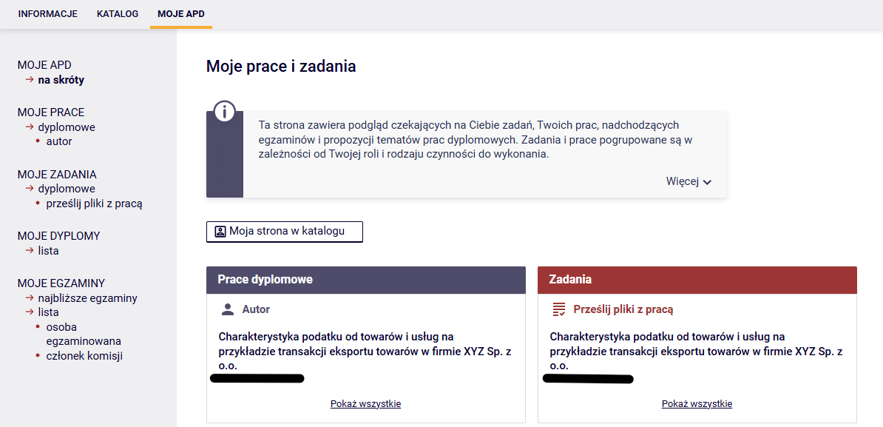
Access to individual stages is possible after entering the "MY APD" tab in the main menu of the system:

In the APD system, several steps (stages) must be completed, during which the work is placed in the system, checked by the anti-plagiarism system and evaluated by the Reviewers. The current progress of work is presented graphically on the path with Work Status, which shows what is to be done in a given step and who is responsible for its implementation:

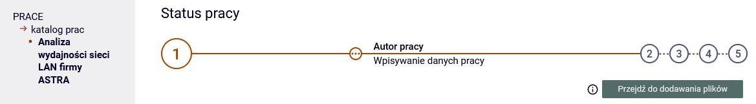

Note: On APK, all users have access to the backlog directory and search engine. The content of the paper and reviews are available only to the Author of the work – Student, Supervisor and Reviewer, Chairman of the Diploma Examination Committee, Employee of the Student Service Center, System Administrator.

  - After creating a task by an Employee of a unit serving Students, the Student is given the opportunity to upload the work to the APD system. The student performs step "1. Entering thesis data", i.e. enters – in Polish and English – the title of the work, abstract and keywords (fig. below). Then click on the "Proceed to Add Files" button and proceeds to step "2. Uploading files with work".

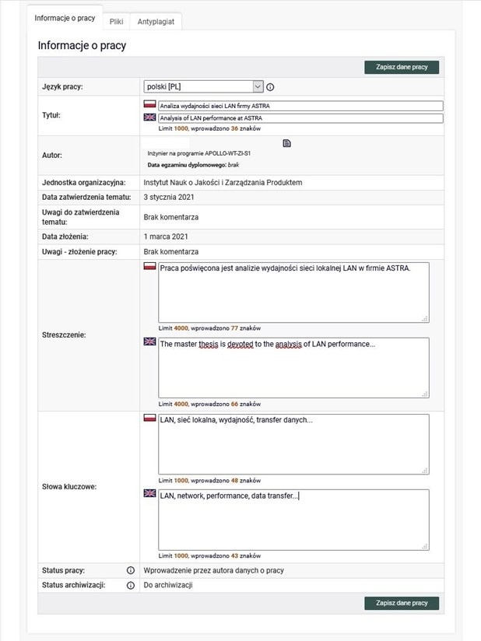

  - In the APD system, the Student performs step "2. Uploading files with the thesis", in which the thesis file in PDF format and possible attachments to the thesis is included, and the Statement on the use of artificial intelligence Appendix 3 to the Diploma Thesis Defense Procedure – file type "Other" (fig. below). Then click on the "Submit for approval by the Supervisor" button (Supervisor) and proceed to step "3. Data Acceptance".

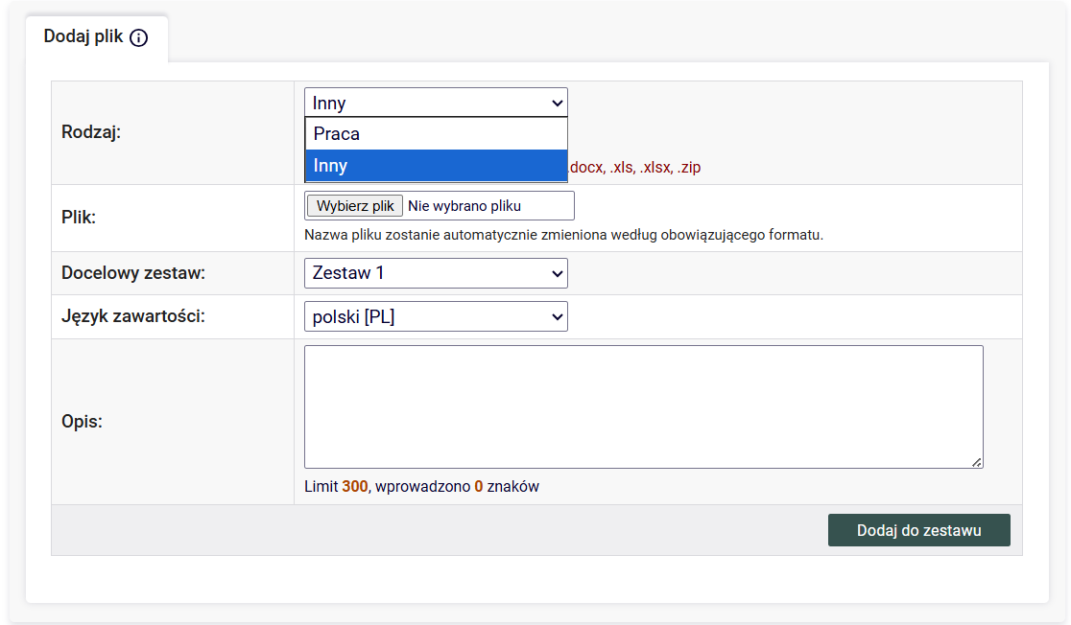

  - In the APD system, the Supervisor performs step "3. Data acceptance", i.e. checks the work submitted by the Student and additional data (title, abstract, keywords), and then:
a. if the work needs to be improved, click on the "Submit for improvement" button (then there is an option to enter a comment regarding the reason for directing the work for improvement and the work itself returns to step "2. Uploading work files")
a. if the work does not require improvement, the Supervisor sends it for verification in the JSA (Uniform Plagiarism Protection System) by clicking on the "Order a test" button (fig. below).
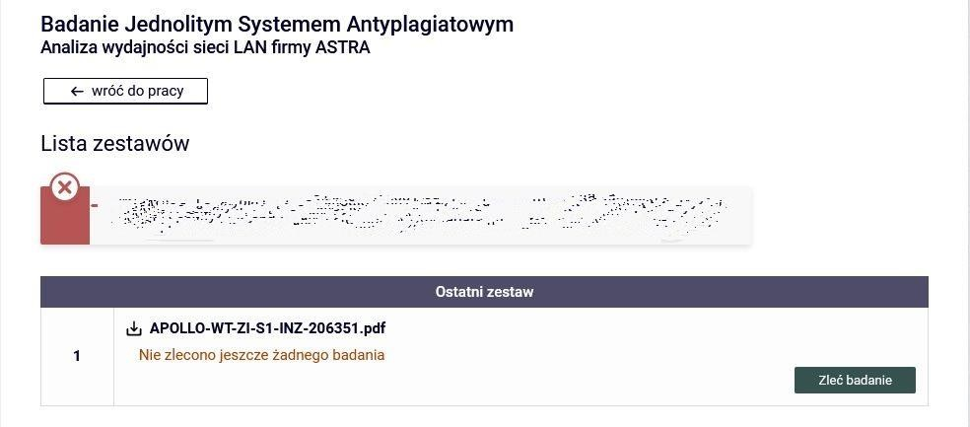

  - Once the JSA has completed the survey, the work study report is available in the APD system. Then the Supervisor reads the report of the work study and then:
- if the result obtained is sufficient, it accepts the report from the JSA system (fig. below).

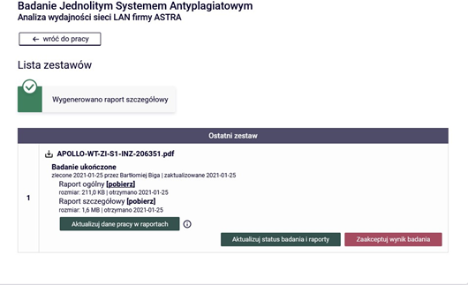

- if the result obtained is not sufficient, and he/she believes that it requires improvement on the part of the Student, he/she clicks on the "Submit for improvement" button and thus sends the work to the Student for improvement. Then the work returns to step
"2. Sending files with the thesis" in the APD system, and the Procedure of remote defense of the diploma thesis begins with point 1.3.

The diploma thesis is considered to have been submitted within the deadline after meeting the following conditions:
1) passing all classes included in the study program, including the diploma seminar; 2) entering the written diploma thesis into the APD system by the student; 3) verification of the written diploma thesis by the Supervisor using the Uniform Anti-Plagiarism System, confirmed in the APD system with the annotation "I accept", constituting the acceptance of the final version of the diploma thesis.

Crediting of the diploma seminar takes place after the final acceptance of the diploma thesis, in accordance with point 3 above.

  - The Supervisor informs about the accepted General Report on the JSA examination and proposes the Reviewer by contacting the Student Service Center by phone or sending an e-mail to the Employee of the Student Service Center.

1.7. After the Student submits a statement of readiness to defend himself, the employee of the Student Service Center creates and launches the Circulation in the USOSweb system.

Note: The student should obtain a settlement with all departments at the University, i.e. the Main Library, the Student and PhD Student Settlements Department and the student dormitory.

  - tag. The student downloads and fills in the form available in the USOSweb system without undue delay: Statement of readiness to defend the diploma thesis ("Appendix 4 to the Diploma Thesis Defense Procedure"), including the necessary additions with:
- Supplementary Information for the Diploma Supplement
- Statement regarding the processing of the Graduate's personal data
- Information for Graduates on the processing of personal data
- Application for a copy of the diploma/supplement in a foreign language (optional)

At this stage, the above-mentioned documents are sent via the USOS system.

Submitting applications is available after logging in to the USOSweb system in the menu "FOR STUDENTS -> APPLICATIONS -> Submit a new application".

The Student delivers to the Student Service Center on the day of the defense of the diploma thesis:
- printed and signed: the originals of the "Statement on the Use of Artificial Intelligence Appendix 3" and the originals of the documents forming the "Appendix 4 to the Diploma Thesis Defense Procedure";
- downloaded from the APD system:
- general report on the JSA examination
- worksheet ("Appendix 5 to the Diploma Thesis Defense Procedure")
- a statement on making the thesis available ("Appendix 6 to the Diploma Thesis Defense Procedure").

1.9. An employee who has been appointed as a Reviewer is visible to the Student in the APD system.
1.10. After the review is approved by the Supervisor and the Reviewer, the system proceeds to step
"5. Work ready to defend".
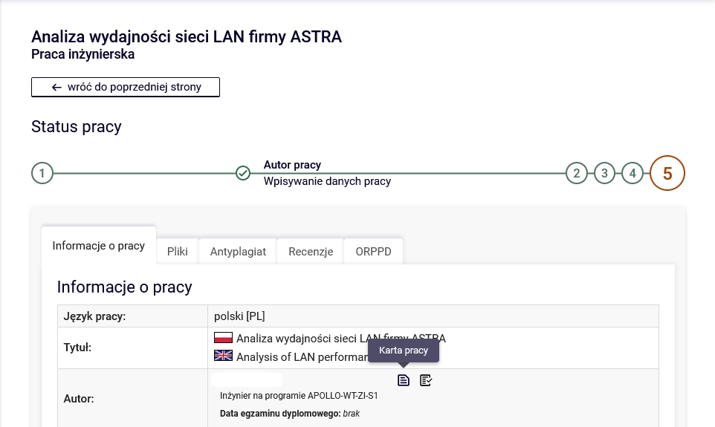

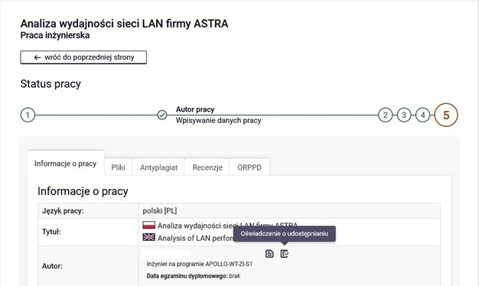

Diploma exam

The diploma exam is conducted stationary with the use of technical devices necessary to operate the APD and USOS systems and with the use of the Employees' work email accounts located in the uek.krakow.pl domain

  - The prerequisites for conducting the diploma exam are:
    - the Student meets all the requirements set out in Chapter 6. Regulations of studies at the Krakow University of Economics,
    - access of the Members of the Diploma Examination Committee (the Chairperson of the Committee, the Supervisor and the Reviewer, and the Member, in a situation where he/she replaces the Reviewer in the Committee) to a computer, a stable Internet connection;

Note: Members of the Committee should check the technical condition of computers and Internet access before the exam;

- The student is obliged to take the diploma exam in appropriate clothing, in accordance with academic customs, during the defense of the diploma thesis.

2.2. At least 7 days before the scheduled date of the diploma exam, the Employee of the Student Service Center, after prior arrangements, sends to the e-mail accounts of the Student and the Members of the Diploma Examination Committee (i.e. the Chairman, Supervisor, Reviewer and Member, in a situation where he/she replaces the Reviewer in the Committee) information about the date, time of the diploma exam and the designated room in which the exam will take place. to the Chairman of the Diploma Examination Committee. In the content of the message, the employee of the Student Service Center sends a list of people taking the diploma exam on a given day.

2.3. On the date of the exam (date, time), the Student or a group of Students and all Members of the Diploma Examination Committee should be present five minutes before the scheduled date of its commencement in the room designated by the Employee of the unit serving Students.

2.4 The diploma exam begins with the drawing of the first question or the first question being asked by the Supervisor. This is followed by the Student's answer to the question and a discussion led by the Supervisor. With the second and third questions, respectively, the situation repeats itself. Additional questions may be asked by all Members of the Diploma Examination Committee (Chairperson, Supervisor, Reviewer and Member, in a situation where he/she replaces the Reviewer in the Committee). If the Student's answers require a written, graphic form or presentation of photos and drawings, then before the diploma exam the Student Service Center Employee should inform the Student Service Center Employee about the preparation of an additional computer in the defense room with a connection to a multimedia projector, flipchart board or other equipment.

2..5. After conducting the diploma exam, the Commission determines the grade from the diploma exam during the classified part of the exam, and in the case of a positive result of the exam, also the final result of studies.

2.6. After re-inviting a Student or a group of Students to a meeting with the Diploma Examination Committee, the Chairperson of the Committee announces the result of the Diploma Examination determined by the Committee. In the event of a positive result of the diploma examination, the Chairman of the Commission also announces the final result of studies and announces the decision on awarding the appropriate professional title.
2.7. When receiving the student's diploma in the case of second-cycle studies, the Student submits the student ID card to the Student Service Center.

List of attachments to the Diploma Thesis Defense Procedure:

- Appendix 3. Statement on the use of artificial intelligence
- Appendix 4. Statement of readiness to defend the diploma thesis (with attachments 4a-4d) – to be filled in by the Student
- Appendix 5. Diploma Thesis Card – to be filled in by the Student
- Appendix 6. Statement on making the work available – to be filled in by the Student

If you experience technical problems, you can get help from:

- JSA system – uasa@uek.krakow.pl
- APD system – tel. (12) 293-58-25, email: apd-pomoc@uek.krakow.pl
- circulation – tel. (12) 293-58-25, email: usosweb@uek.krakow.pl
1) Appendix 3. to the Diploma Thesis Defense Procedure

Statement on the use of artificial intelligence

I hereby declare that in the process of preparing this diploma thesis, I did not use the following artificial intelligence tools:
…………………………………………………………………………………………………………………………………………………………………….……………….…………………..
............................................................................................................................................................................................................, solely for the purpose of:
……………………………………………………………………………………………………………………………………………………………………………………………………………………………………………………………………………………………………………

All substantive analyses, critical verification, interpretation of results, especially in terms of the possibility of generating false or incomplete information, plagiarism or lack or incorrect attribution of authorship, as well as the final editing of the text of the diploma thesis were carried out independently. I take full responsibility for the content of the diploma thesis, including its substantive, linguistic, ethical correctness and compliance with the law.

……………………..
(signature of the Student)

2) Appendix 4. to the Diploma Thesis Defense Procedure

Statement of readiness to defend the diploma thesis

…………………………….......... Krakow, on ...................

(Student's name)

……………………

(album no.)

……………………

(degree program)

……………………

(form and mode of study)

………………………

(contact phone)

Director of the Institute ...................

…………………………………….

I declare that all stages of education have been completed by me, and my diploma thesis entitled ......................................................................................................

……………………………………………………………………………...………………………….

…………………………………………………………………………………………………………

was adopted on ..................... by .................................................................
(title, name, surname of the Supervisor)

I kindly ask you to admit me to the diploma exam and appoint a Reviewer.

I acknowledge that my diploma thesis has been verified for plagiarism in the Unified Anti-Plagiarism System on the basis of the applicable regulations, and after a positive result of the diploma exam, it will be added to the National Repository of Written Diploma Theses in the Integrated Information System on Higher Education and Science POL-on maintained by the Minister of Education and Science, with the proviso that this repository does not contain papers containing information protected under the provisions on the protection of classified information.

………………………..
(signature of the Student)

Attachments:

a. Supplementary Information for the Diploma Supplement
b. Statement regarding the processing of the Graduate's personal data

c. Information for Graduates on the processing of personal data
d. Application for a copy of the diploma/supplement in a foreign language (optional)

Response to the Statement of Readiness to Defend the Diploma Thesis:

I declare the completion of all stages of education and the fulfilment of the conditions for admission to the diploma exam.

I appoint the following as the Reviewer of the diploma thesis:

…………………………………………………………….………………………………………

………..…………………

(signature of the Director of the Institute)

2) Appendix 4a.
to the Statement of Readiness to Defend the Diploma Thesis

Supplementary Information for the Diploma Supplement

…………………………….......... Krakow, on ...................

(Student's name)

……………………

(album no.)

……………………

(degree program)

……………………

(form and mode of study)

………………………

(contact phone)

Internships completed during studies (name of institution, duration):
......................................................................................................................................................................

......................................................................................................................................................................

Participation in Scientific Clubs (*):
......................................................................................................................................................................

......................................................................................................................................................................

Prizes received (*):
......................................................................................................................................................................

......................................................................................................................................................................

Scholarships for outstanding achievements in science (*) and sports (*):
......................................................................................................................................................................

......................................................................................................................................................................

Scholarship Trip, e.g. ERASMUS (name of the program, name of the University, semester of the trip)
......................................................................................................................................................................

......................................................................................................................................................................
Participation in the ACCA path (*): □ YES □ NO

……………………..
(signature of the Student)

(*) If the statement specifies activities, it is imperative to attach appropriate documents (e.g. certificate, photocopy of the certificate) confirming the indicated information.

2) Appendix 4b.
to the Statement of Readiness to Defend the Diploma Thesis

Statement regarding the processing of the Graduate's personal data



Name *

Correspondence address *

E-mail address *

Contact phone

Institute

Degree program

* - mandatory data

Pursuant to Article 6(1)(a) of Regulation (EU) 2016/679 of the European Parliament and of the Council on the protection of natural persons with regard to the processing of personal data and on the free movement of such data, and repealing Directive 95/46/EC (General Data Protection Regulation - GDPR) of 27 April 2016 (Journal of Laws of 27 April 2016). OJ L 2016, No 119):

□ YES □ NO

I consent to the processing of my personal data in the scope of contact phone, institute and degree program by the Krakow University of Economics in order to monitor the professional careers of KUE Graduates enabling the KUE to adapt the study program to the needs of the labor market.

□ YES □ NO

I consent to the processing of my personal data in the form of an e-mail address and a contact phone number for the purpose of sending information about events (conferences, sessions, deliberations, congresses, job fairs, etc.) organized by the Krakow University of Economics.

…………………………………………………..

(date and signature of the Graduate)

2) Appendix 4c.
to the Statement of Readiness to Defend the Diploma Thesis

Information for Graduates on the processing of personal data

In accordance with Regulation (EU) 2016/679 of the European Parliament and of the Council on the protection of natural persons with regard to the processing of personal data and on the free movement of such data, and repealing Directive 95/46/EC (General Data Protection Regulation) of 27 April 2016 (Official Journal of the European Union). UE L 2016, No. 119, hereinafter referred to as GDPR), we hereby inform that:

- The administrator of your personal data is the Krakow University of Economics (KUE) with its registered office in Krakow, 27 Rakowicka Street, 31-510 Krakow (hereinafter: "Administrator");
- Contact details of the Data Protection Officer: iod@uek.krakow.pl.
- Your personal data on the basis of and to the extent indicated in Article 352(15) of the Act of 20 July 2018. The Law on Higher Education and Science (i.e. Journal of Laws of 2022, item 574, as amended), i.e. name and surname, correspondence address and e-mail address, will be processed for the purpose of monitoring the professional careers of KUE Graduates enabling the KUE to adapt the study program to the needs of the labor market. After you have given your consent, other personal data provided in the statement on the processing of the Graduate's personal data will be processed for the same purpose, i.e. the contact phone, the institute and the degree program.
- After your consent, your personal data will also be processed for the purpose of sending information about events (conferences, sessions, deliberations, congresses, job fairs, etc.) organized by the Krakow University of Economics. The basis for the processing is your consent (Article 6(1)(a) of the GDPR).
- Your personal data may be made available to appropriate recipients, in particular external entities providing IT or legal services to the administrator or institutions authorized to control the administrator's activities and entities authorized to access data on the basis of legal provisions.
- Your personal data will be processed for a period not longer than 10 years from the date of your graduation or until you withdraw your consent.
- Your consent to the processing of your personal data is always voluntary.
- You have the right to request from the administrator access to your personal data, their rectification, deletion or restriction of processing, as well as the right to object to processing and the right to transfer data - in the cases and on the terms specified in the provisions of the GDPR;
- To the extent that the basis for the processing of your personal data is consent, you have the right to withdraw it at any time. The withdrawal of consent does not affect the lawfulness of processing that was carried out on the basis of consent before its withdrawal.
- You have the right to lodge a complaint with the supervisory authority – the President of the Office for Personal Data Protection, if you believe that the processing of your personal data violates the provisions of the GDPR.
- Your personal data will not be subject to automated decision-making or profiling.
- The Administrator will not transfer your data to third countries.

I have read the above information: ….........................................................
(date and signature of the Graduate)

2) Appendix 4d.
to the Statement of Readiness to Defend the Diploma Thesis

Application for a copy of the diploma/supplement in a foreign language

…………………………….......... Krakow, on ...................

(Student's name)

……………………

(album no.)

……………………

(degree program)

……………………

(form and mode of study)

………………………

(contact phone)

………………………

(mailing address)

Director of the Institute ...................

…………………………………….

I kindly ask you to issue a copy of the diploma of completion of long-cycle master's studies / master's studies / bachelor's studies in ........................ /supplement in .....................

I passed my diploma exam on .................................. in the degree program ..........................................................

………………………..
(signature of the Student)

3) Appendix 5. to the Diploma Thesis Defense Procedure

Krakow, ...................

Krakow University of Economics ARCHIVED IN KUE APD
…………………… (archiving confirmation)

(Institute)

Thesis card

Names:
Name:
PESEL:
Album number:
Studies:
Diploma Code:
Diploma description:
Thesis Supervisor:
Thesis title in Polish:
Thesis title in English:
Keywords:
Thesis number:
Short summary:

Is the thesis subject covered by legally protected secrecy:
Does the thesis contain information subject to protection under the regulations on the protection of classified information:
Date of submission:
Reviews have been submitted and archived at APD:
Supervisor:
Reviewer:

- Appendix 6. to the Diploma Thesis Defense Procedure

STATEMENT ON MAKING THE WORK AVAILABLE
……………………………..........

(Student's name)
……………………

(album no.)
……………………

(degree program)
……………………

(name of the Institute)
Krakow University of Economics

- I declare that I have familiarized myself with the procedures of anti-plagiarism verification and archiving of diploma theses in force at the Krakow University of Economics (University).

- I declare that the diploma thesis entitled ............................................................., entered by me into the system of the Diploma Theses Archive (APD) of the University Study Service System (USOS):
- is my authorship / co-authorship in part ........ * and does not infringe the copyrights of third parties, other rights or personal rights protected by law,
- does not contain data/information obtained in a legally prohibited manner,
- is related to my education at the University,
- has not previously been the basis for any other procedure related to the awarding of professional titles, degrees or academic titles,
- is the final version presented for defense at the University.

- I hereby declare that I have been informed that my diploma thesis together with its descriptive metadata containing my personal data will be stored/archived in the electronic database of written diploma theses of the University (Archive of Diploma Theses) for a period of 50 years.

- I agree to store/archive and make available the diploma thesis to the extent necessary to protect my right to authorship of the work or the rights of third parties and to use the diploma thesis to perform anti-plagiarism verification of other works/documents, as part of the anti-plagiarism system used at the University, as well as to use it for operational and statistical purposes related to the operation of this system.

- Consents are granted free of charge, for an indefinite period of time and remain valid also in the event of transferring all or part of the electronic database of the University's written diploma theses and doctoral dissertations to another database or system, used by the University for anti-plagiarism verification or archiving.

- At the same time, I acknowledge that in the event that in the diploma thesis constituting the basis for the award of a professional title, an act consisting in attributing to oneself the authorship of a significant fragment or other elements of someone else's work or scientific arrangement has been committed, the Rector of the University will declare the diploma invalid (Article 77(5) of the Act of 20 July 2018 on the Law on Higher Education and Science).

- I express/do not agree* to make my work available on the Internet.

………………………..
(Author's signature)

^{* delete unnecessary items;}
__________________________________________________

The diploma thesis is stored in an electronic version in the APD system of the University at the number ..............

ATTENTION! In the case of a diploma thesis covered by a confidentiality clause, i.e. if the thesis contains information constituting a trade secret or classified information, subject to protection under the regulations on the protection of classified information, this procedure should be applied taking into account the priority of separate rules resulting from the Procedure for Covering Diploma Theses with a Confidentiality Clause (including marking the thesis, the possibility of checking in JSA, storage, archiving).
Delete unnecessary.
Indicate the type/name of the AI tool and its version.
The type of activity for which artificial intelligence tools have been used should be indicated, e.g. translating fragments of scientific literature available in foreign languages, assisting during the process of searching and pre-selecting bibliographic sources, using a data analysis tool, etc.
Select the appropriate option.
Delete unnecessary.
A copy of the diploma in English, French, Spanish, German, Russian or another foreign language in which education was conducted at these studies.
A copy of the diploma supplement in English or in another foreign language in which education was conducted during these studies.
To be completed in the case of submitting an application after the deadline for defense.
The student downloads and prints from the APD system.
The student downloads and prints from the APD system.
In the case of diploma theses covered by the confidentiality clause, the above consent is limited only to allowing the diploma thesis to be stored and archived in the University's anti-plagiarism system and used for operational and statistical purposes.

